Graphical Abstract

A multi-model generalisable ecosystem risk assessment methodology for the Massaciuccoli Lake basin wetland
Gian Luca Vannini, Gianpaolo Coro
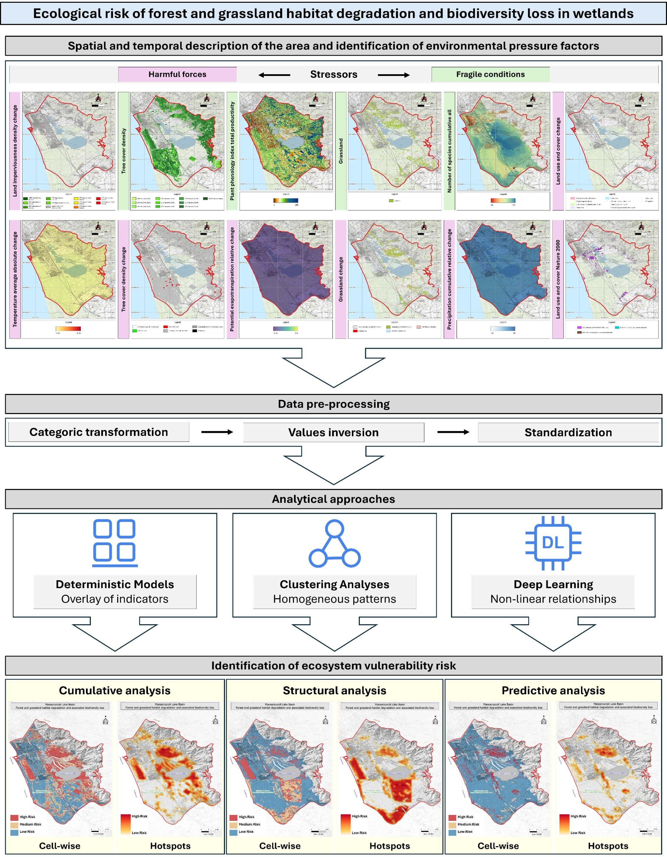

Highlights

A multi-model generalisable ecosystem risk assessment methodology for the Massaciuccoli Lake basin wetland
Gian Luca Vannini, Gianpaolo Coro

- Multi-model ecosystem risk assessment for the Massaciuccoli wetland basin in Italy
- Comparison of deterministic, clustering, and deep learning models
- Identification of ecosystem risk hotspots
- Integrated FAIR geospatial data for robust and interpretable risk mapping
- Reusable methodology to support conservation and land-use planning

A multi-model generalisable ecosystem risk assessment methodology for the Massaciuccoli Lake basin wetland
Gian Luca Vannini^{a,b}, Gianpaolo Coroª
ªInstitute of Information Science and Technologies ”A. Faedo” of the National Research Council of Italy (CNR-ISTI), Via Moruzzi 1, Pisa, 56124, Italy
^{b}University of Pisa, Lungarno Pacinotti, Pisa, 56126, Italy

Abstract
Wetlands are among the ecosystems most exposed to degradation due to the con-current action of anthropogenic pressures and climate-related stressors, particularly in highly anthropised landscapes. This study presents a multi-model comparative methodology for assessing and mapping the risk of forest and grassland habitat degra-dation and associated biodiversity loss in wetland environments. It integrates three complementary, unsupervised models applied to a harmonised geospatial dataset:
(i) a deterministic cumulative overlap index, (ii) a multivariate clustering model, and (iii) a predictive, deep learning model based on a Variational Autoencoder com-bined with cluster analysis. The methodology is applied to the Massaciuccoli Lake basin (Tuscany, Italy), a Ramsar-listed wetland characterised by intense land-use pressure and high ecological value. Using 12 stressor variables describing ecological fragility and harmful driving forces at approximately 50 m spatial resolution, the models produced spatially explicit risk hotspot distribution maps consistent with previous localised studies. Results also highlight complementarity aspects among the models: deterministic mapping identified areas of strong stressor co-occurrence; clustering revealed structurally homogeneous ecological conditions; and deep learning captured non-linear patterns and anomalous configurations associated with emerging ecosystem risks. Areas consistently classified as medium or high risk across multiple models delineated robust priority hotspots, while divergent classifications identified transitional or uncertain conditions requiring further investigation. The proposed methodology is re-applicable to other wetlands to enhance the robustness and inter-pretability of ecosystem risk assessments. It provides a reproducible, scalable tool to support conservation planning, environmental management, and spatial decision-making in wetlands affected by complex, interacting stressors.
Keywords: Ecosystem risk assessment, Environmental stressors, Geospatial data,

Preprint submitted to Ecological Informatics January 26, 2026

Cumulative impacts, Unsupervised learning, Anomaly detection, Deep learning

Introduction
Wetlands represent some of the most complex, dynamic, and functionally impor-tant ecosystems on the planet [1]. They host exceptionally high levels of biodiversity [2, 3, 4, 5], play a key role in carbon sequestration [6, 7, 8, 9, 10, 11, 12, 13, 14],
contribute to local and regional climate regulation [15, 16, 17, 18, 19], and provide es-
sential ecosystem services, including water purification [20, 21, 22, 23, 24], flood peak
mitigation [25, 26, 27, 28], and support for agricultural activities and surrounding
socio-economic systems [29, 30, 31, 32, 33, 34, 35].
Despite their ecological and socio-economic importance, wetlands are among the ecosystems most vulnerable to rapid degradation caused by combined pressures, in-cluding human activity, land-use intensification, habitat fragmentation, diffuse pol-lution, and changes in hydrological regimes [36, 37, 38, 39, 40, 41, 42, 43]. These drivers are further amplified by climate change, which increases ecosystem vulnera-bility through shifts in temperature and precipitation patterns, sea-level rise, changes in water availability, and a growing frequency of extreme events [44, 45, 46, 47, 48,
49, 50].
Forest and grassland habitats, which constitute the structural and functional matrix of many wetland landscapes, are among the components most sensitive to these pressures [51, 52, 53, 54]. They ensure ecological connectivity and functional
support for numerous species [55, 56, 57, 58, 59, 60], while their deterioration can cause cascading effects on species richness, ecosystem functioning, and long-term resilience [61, 62, 63]. These dynamics are particularly critical in Mediterranean contexts, already characterised by water stress and strong anthropogenic pressure [64, 65, 66, 67, 68, 69].
Assessing ecological risk in such contexts requires analytical tools that can com-bine multiple stressors operating across various spatial and temporal scales. Tra-ditional deterministic models and expert-based assessments, while still valuable for local-scale decision-making, have limitations related to subjectivity, restricted rep-resentation of non-linear relationships, and limited transferability across ecological contexts [70, 71, 72, 73, 74].
Recent advances in environmental monitoring, combined with the increasing availability of geospatial data and the rapid development of quantitative analytical methods, have created new opportunities for developing spatially explicit ecological risk assessment systems [75, 76, 77, 78, 79]. These approaches enable the integration of heterogeneous variables and the modelling of non-linear relations between stressors and ecosystem responses, overcoming some of the limitations of purely deterministic frameworks [80, 81, 82].

In this context, our study introduces a multi-model analytical framework for as-sessing the risk of forest and grassland habitat degradation linked to biodiversity loss in wetlands. The novelty of the approach lies in the combination and explicit comparison of complementary modelling paradigms, applied jointly to the same set of harmonised geospatial data. Specifically, the framework integrates a determinis-tic cumulative risk index, a multivariate clustering technique, and an unsupervised deep learning model, enabling the identification of reliable risk hotspots supported by multiple models and the detection of transitional or uncertain conditions char-acterised by differing model responses. By systematically comparing risk models, the proposed methodology enhances the robustness of the assessments and improves their ecological interpretability, offering a reproducible, scalable tool for ecosystem risk analysis in highly anthropised wetland environments.
The methodology was first developed specifically to evaluate the risks associated with changes in the ecosystem state of the Massaciuccoli Lake basin, located in Tus-cany, Italy (Figure 1). However, it was designed to be reusable for other wetlands. The Massaciuccoli Lake basin is notable for being one of the most anthropogeni-cally modified and ecologically sensitive wetlands in central Italy, recognised as a Ramsar site of international significance [83, 84, 85, 86, 87, 88, 89]. The region is characterised by its high ecological importance and socio-economic relevance, serving as a major tourist destination and a biodiversity hotspot that continues to attract significant interest from local communities, visitors, and researchers alike [90, 91]. Spanning an area of 114 km², the Massaciuccoli Lake basin is bounded to the north by the Camaiore River, to the east by the Oltre Serchio Mountains, to the south by the Serchio River, and to the west by the Tyrrhenian Sea. The lake itself encom-passes approximately 13 km², with water depths varying from 1 to 2.5 m and an estimated total volume of about 14 Mm³ [92, 93, 94, 90]. The basin’s hydrological regime is predominantly pluvial, receiving precipitation from the eastern mountains and surrounding agricultural landscapes. The basin is subject to significant human pressures, with agriculture accounting for approximately 40% of local activities, in-cluding farming, cereal and industrial production, horticulture, olive cultivation, and related infrastructure such as highways and railways [95]. Furthermore, the presence of two wastewater treatment plants that discharge effluents directly into the lake has further repercussions for water quality and ecosystem dynamics. The hydrogeologi-cal, chemical, and environmental characteristics of the basin are critical determinants of habitat suitability for both native species (black bullhead, eel, tench, largemouth bass, carp, heron, kingfisher, and others) and non-native species (including sheatfish and red swamp crayfish). Additionally, the lake serves a vital role as a stopover along major migratory routes, thereby hosting considerable concentrations of avian

populations and supporting a diverse array of ecosystem services [90, 91]. Like many wetland ecosystems, birds in this region exhibit heightened sensitivity to fluctuations in hydrological and biogeochemical conditions, rendering them particularly vulnera-ble to the current and anticipated impacts of climate change [96, 97, 98, 99].
The implications of climate change on the Massaciuccoli ecosystem are substan-tial. Projections suggest that rising temperatures and increasing aridity may grad-ually render habitat conditions uninhabitable for many avian species by 2100 [87]. These shifts are expected to trigger alterations in the distribution of both terres-trial and aquatic organisms, with cascading consequences for ecosystem services and the associated socio-economic values [99, 100, 94, 96, 101]. In response to these challenges, policy-makers are investigating mitigation and adaptation strategies, pri-marily focused on ensuring the long-term availability of water within the lake [102]. Nonetheless, such initiatives necessitate robust scientific support to assess the timing of ecosystem transitions and to identify the species most at risk, thereby facilitating informed management and conservation planning.
This paper makes a significant contribution to the existing body of knowledge on the ecosystem status of the Massaciuccoli Lake basin and aims to support local authorities in developing effective conservation and mitigation strategies.
The paper is organised as follows: Section 2 defines ecosystem risk assessment, illustrates current approaches, presents the studies available for the Massaciuccoli Lake basin, and highlights the complementary aspects introduced by our methodol-ogy. Section 3 describes the data available for the analysed area, the methodology pipeline, and the evaluation strategy. Section 4 reports the results of qualitative and quantitative evaluations, and, finally, section 5 summarises the main findings, limitations, and future work.

Overview
Ecosystem Risk Assessment (ERA) is a methodological framework for identifying, characterising, and spatially representing the likelihood that an ecosystem undergoes a critical transition from one state to another, which would involve changes in the structure, functioning, or provisioning of ecosystem services due to natural and an-thropogenic pressures [17, 103, 104].
Unlike impact assessments focused on single stressors, ERA explicitly addresses the concurrent action of multiple pressure factors, their interactions across different spatial and temporal scales, and the non-linear responses of ecological systems [105, 106].
In wetlands, ERA is particularly relevant because ecosystem dynamics are gov-erned by strong interconnections among hydrology, vegetation, biodiversity, climate

variability, and land-use practices, which sustain water regulation, carbon storage, and biodiversity hotspot functions [2, 6, 107]. At the same time, these intercon-nections make wetlands highly productive but also exceptionally vulnerable to the cumulative effects of anthropogenic pressures, including land conversion, habitat fragmentation, diffuse pollution, and hydro-climatic alterations, increasing the like-lihood of regime shifts and difficult-to-reverse ecosystem changes [108, 109, 39].
Ecosystem risk does not merely coincide with observed degradation but also en-compasses conditions that increase the probability of future ecosystem changes, such as biodiversity loss, habitat fragmentation, functional simplification, or reduced re-silience [110, 111, 112]. ERA thus represents an analytical approach oriented toward prevention, prioritisation, and adaptive management rather than a purely retrospec-tive diagnosis.
Several methodological frameworks have been proposed for ERA, differing in their theoretical assumptions, data requirements, and analytical objectives. ERA has his-torically relied on deterministic and expert-based approaches, including multi-criteria decision analysis schemes and cumulative impact maps, which are still widely adopted due to their transparency, interpretability, and ease of communication in support of environmental policy [113, 114, 105]. These approaches are based on the spatial aggregation of standardised stressors but exhibit well-known limitations related to subjectivity in weighting, assumptions of linear interdependence or independence among factors, and limited transferability across heterogeneous ecological contexts [115, 116].
To overcome some of these limitations, statistical and multivariate approaches have been proposed, based on clustering techniques and latent-variable analysis, that aim to identify recurring ecological conditions and emergent gradients directly from the data [117, 118, 119, 120, 121]. These methods reduce subjectivity and capture co-occurrence patterns among stressors, but often remain descriptive and limited in representing strongly non-linear relations.
More recently, the growing availability of geospatial data has fostered the adop-tion of machine learning and deep learning approaches in ERA [122, 123, 124]. In particular, unsupervised methods such as advanced clustering, anomaly detection, and deep generative models based on autoencoders enable the identification of latent structures, emergent ecological gradients, and early-warning signals of change, mod-elling non-linear dependencies and integrating heterogeneous data [125, 126, 127]. However, single-method applications still face challenges in ecological interpretabil-ity, comparability of results, and robustness [128, 129].
An increasing number of studies are highlighting the need for integrated and multi-source frameworks that combine cumulative, structural, and data-driven ap-

proaches within a coherent architecture, leveraging their complementarity and im-proving the reliability of ecosystem risk assessments [130, 131, 132, 133, 134, 135,
136, 121, 124, 137].
As for the Massaciuccoli lake basin, ecosystem assessment studies have focused on specific subregions and have investigated (i) hydrological dynamics and water quality, including nutrient loads, hydrodynamic instability, subsidence of reclaimed peat soils, and peat oxidation processes [88, 138, 139]; (ii) anthropogenic pressures related to intensive peri-lacustrine agriculture, urban and infrastructural expansion, and diffuse contamination, resulting in habitat fragmentation and loss of ecological connectivity [140, 94, 85]; (iii) biological components and habitats of community interest [141], including coastal pine forests, meadow-woodland mosaics, and hy-grophilous vegetation, as well as phytosanitary and microclimatic issues [86, 84]; and (iv) bioclimatic signals and potential impacts of climate change on species and habitats [87, 142].
Despite the richness of thematic studies, these analyses are largely sectoral or limited to specific portions of the territory and single time horizons [85]. To date, there has been no comprehensive, spatially explicit assessment of ecosystem risk across the entire basin that integrates anthropogenic and climatic pressures with biodiversity and ecological fragility indicators using multivariate and comparative approaches. A major obstacle has historically been the lack of harmonised, multi-temporal geospatial data sets, which has prevented the systematic application of advanced ERA methodologies. Recently, this gap has been partially filled by the availability of an open-access geospatial Atlas of the Massaciuccoli basin, covering conditions from the 1950–1980 period to future climate scenarios between 2050 and 2100 [143]. Based on this information, the present study represents the first attempt to apply a multi-model and comparative ERA methodology to the entire basin, with a specific focus on the degradation of forest and grassland habitats and the consequent loss of biodiversity.
The main novelty of the methodology proposed in this paper, compared to other
ERA methods, lies in the explicit integration and systematic comparison of three an-alytical paradigms (deterministic, statistical, and deep learning). The deterministic cumulative index provides an inclusive and precautionary perspective, highlighting areas where multiple stressors co-occur and supporting exploratory and preventive planning. The clustering-based approach offers a structural interpretation of the risk-variables vector space, identifying homogeneous ecological conditions and clar-ifying how specific stressor combinations characterise different landscape portions. The deep learning component, based on a Variational Autoencoder integrated with cluster analysis, was newly designed for the present study. It introduces a predictive

dimension, enabling the detection of non-linear patterns and anomalous configu-rations that may signal emerging ecosystem changes. These models were selected among baselines that demonstrated effectiveness in different contexts of anomaly de-tection [125, 144, 145], including ecosystem risk assessment and ecological modelling in marine and terrestrial areas [146, 147, 132, 148, 119, 121, 149, 150, 151]. In partic-ular, the work in [124] presents a comprehensive comparison of the pros and cons of the mentioned models and provides guidance on selecting the most suitable model for specific assessment purposes (general vs. localised). Following the advice from this work, we reused the Multi K-means approach, extended the Variational Autoencoder model by combining it with cluster analysis to refine the assessments, and introduced a cumulative analysis representing a traditional approach to risk assessment (Section 3.2).
Rather than identifying a single optimal model, the presented methodology anal-yses convergences and divergences among the models to provide a hierarchical, more robust representation of ecosystem risk. Areas identified as high-risk by multiple models can be interpreted as priority hotspots, while divergent classifications high-light transitional or uncertain conditions that warrant further investigation. This multimodal strategy enhances interpretability, reduces methodological biases, and increases the reliability of spatial risk assessments. At the same time, it provides a scalable and reproducible scheme transferable to other wetland contexts charac-terised by heterogeneous stressors and high geodata availability.

Methods
The assessment of the Massaciuccoli Lake basin’s ecosystem risks related to for-est and grassland habitat degradation and biodiversity loss was conducted using a multi-phase methodological framework (Figure 2) designed to ensure analytical ro-bustness, transparency, and reproducibility. The approach integrates deterministic, clustering, statistical, and deep learning strategies, supported by an interpretative procedure for detected clusters. Section 3.1 reports the details of the data collec-tion and preparation phase, whereas Section 3.2 explains the modelling methodology. The code implementing this workflow was developed in R and is openly available on Zenodo and GitHub (Software and data availability).
  - Data
Data collection and preparation was composed by the following phases, detailed in the next sections: (i) spatial and temporal characterisation of the study area, through environmental, climatic, biological, and anthropogenic geospatial data; (ii)

definition and identification of ecological stressor variables, to distinguish ecosys-tem fragility conditions from harmful driving forces; and (iii) data preparation and standardisation, which includes variable reprocessing, spatial alignment, and trans-formation into a unified dataset suitable for multivariate analysis.
    - Spatio-temporal description of the study area
To obtain a comprehensive and coherent environmental characterisation of the study area, a publicly available cartographic dataset on Zenodo was used [152, 143]. Its content is described in a geographic Atlas of the Massaciuccoli Lake Basin, which provides a comprehensive description of the environmental variables and active driv-ing forces acting in the ecosystem [153]. The methodology that led to the realisation of this repository was based on FAIR (Findable, Accessible, Interoperable, Reusable) principles and a semi-automated workflow for data collection and harmonisation.
The data collection constitutes a spatially explicit environmental knowledge base, organised to support both exploratory and analytical workflows. It includes raster and vector datasets accompanied by standardised metadata, a harmonised coordi-nate reference system (EPSG 4326 - WGS84), and a consistent spatial resolution. Moreover, it provides an integrated spatial and temporal representation of the Mas-saciuccoli Lake basin, describing its climatic, environmental, pedological, anthro-pogenic, and biological features, with particular emphasis on biodiversity. Overall, this data collection includes 75 geo-variables at a spatial resolution of 0.0005° ×
0.0005° (approximately 50 m × 50 m), distributed across 148 datasets and organ-
ised into five temporal snapshots: remote past (1950–1980), recent past (1981–2015),
present (2016–today), near future (today–2050), and far future (2051–2100). Future projections are provided under the Representative Concentration Pathways (RCP) 2.6, 4.5, and 8.5.
When aligned on a common spatial grid, the database comprises a total of 77,346 georeferenced spatial cells covering the study area. This spatio-temporal structure enables multivariate and multi-temporal analyses and was explicitly designed to sup-port the investigation of long-term environmental processes, ecosystem dynamics, and their responses to climatic and anthropogenic drivers within the Massaciuccoli basin.
    - Definition and identification of ecological stressors
The definition of ecological stressors was based on the specific characteristics of the Massaciuccoli ecosystem. Stressors are driving forces within the ecosystem that can influence changes in the ecosystem status, causing a critical transition [131, 121]. Numerically, a stressor is a spatio-temporal variable whose high values influence the ecosystem status [120, 124]. A stressor variable is defined on a collection of data, like

that of the Massaciuccoli basin Atlas (Section 3.1.1). In our case, a stressor variable could directly correspond to a variable represented in one of the geospatial datasets (e.g., an increase in land imperviousness over the past decade) or to the inverse of a variable (e.g., reduced precipitation as the inverse of the increase of precipitation). Overall, they could be divided into two main categories:
      - Fragile conditions: variables whose high values were associated with the sensi-tivity and resilience of the ecosystem [154, 155, 156];
      - Harmful forces: variables representing direct drivers with negative impact on habitats, potentially causing structural and functional changes [157, 158, 159].
Although the original datasets were characterised by heterogeneous temporal ref-erences (single-year snapshots, short-term change periods, or multi-year reference windows), the stress variables used for this study were selected from levels explic-itly marked as “present” (2016-today) in the Atlas. This time frame referred to recent and current ecosystem conditions, rather than distinct historical phases. Vari-ables aggregated over short time periods in the original dataset (e.g., 2015–2018 or 2020–2025) synthesised recent changes or multi-year baseline conditions that have led to the current state of habitats and biodiversity. The time frame of the analysis can therefore be interpreted as representative of the prevailing ecosystem conditions during 2016–2025, ensuring temporal comparability among stressor variables.
The main objective of the present study was to identify the areas most exposed to forest and grassland habitat degradation and related biodiversity loss; therefore, a target set of 12 related variables (Table 1) was defined based on the Massaciuccoli Atlas, to characterise ecological fragility and degradation processes.
    - Data preparation and standardisation
The variables defined in the previous step were extracted from the Atlas, repro-cessed in the case of inverted variables, and aligned on the same ∼50 m grid. Table 1 summarises the reprocessing operations applied to each stressor variable. A grid-ded dataset was prepared as a table file in comma-separated values (CSV) format to enable multivariate analyses. Each row of this dataset represented a georeferenced spatial cell (or raster pixel, measuring 0.0005° × 0.0005°) within the study area. The columns corresponded to the different stressor variables. To ensure data consistency and reliability, rows were retained only if all variables had non-zero values. This aggregation and cleaning operation yielded 49,382 cells spanning the Massaciuccoli basin.
To enhance comparability among stressor variables and increase the robustness of subsequent analyses, the dataset was further reprocessed through categorical and

numerical transformations. Categorical variables were converted into numerical form using either: (i) a normalised intensity scale ranging from 0 to 1 for variables express-ing proportional information (“Grassland cover”, “Land use and cover Natura 2000 hazard areas”, and “Land use and cover anthropisation increase”), or (ii) a Boolean encoding (1 = presence, 0 = absence) for binary variables (“Tree cover density de-crease” and “Grassland cover decrease”). Finally, unavailable data for numerical variables were reinterpreted when explicit values were unavailable (e.g., as reported for “Land imperviousness density increase”).
All variables were subsequently z-standardised to have a mean of 0 and a standard deviation of 1. This operation allowed direct comparison of high and low values across the variables.
The result of this phase was a stressor-variable table file, ready for analysis by the risk assessment models.
  - Risk assessment
Our ecosystem risk assessment methodology to identify the areas most exposed to forest and grassland habitat degradation and related biodiversity loss, consisted of three main processing steps:
- Step 1: Risk assessment through three complementary models;
- Step 2: Risk assessment refinement to better identify conditions associated with ecosystem-change risks;
- Step 3: Ecosystem-risk hotspot identification to highlight spatialised risk hotspots; The next sections provide detailed descriptions of these steps.
    - Step 1 – Multi-model risk assessment
Three unsupervised, complementary models for ecosystem risk assessment were used to analyse the prepared data, as detailed below.
Cumulative analysis. The first model corresponded to a cumulative overlap index for the stressor variables. This overlap index represented a basic and common approach to risk-area identification. It simulated an intuitive analytical approach by an expert who would overlay the spatial distributions of the stressor variables to identify areas where the highest overlap among the highest values of all variables occurs.
The overlap index measured the degree of overlap between high values in all variables. It was obtained by first calculating the sum of all stressor variables (af-ter standardisation) and then studying the statistical distribution of this sum. The quartiles of the distribution indicated regions of high, medium, or low stressor con-currency, based on the following rules:

- First and second quartiles (< 50th percentile): low risk
- Third quartile (50th - 75th percentile): medium risk
- Fourth quartile (> 75th percentile): high risk
This model classified overall 12,346 cells as high risk, 12,345 as medium risk and 24,691 as low risk. The cells associated with a high risk included high values for most stressor variables, i.e., a high overlap between strong harmful forces and peculiarly fragile conditions. Consequently, they could be associated with a high risk of potential ecosystem change due to this cumulation. Therefore, the model’s output represented a cumulative analysis of ecosystem risk.
As output, the model enriched the stressor-variable table with an additional column reporting the overlap index classification for each row (i.e., each cell-wise stressor-variable vector).
Although powerful and interpretable, this approach had two main limitations: the exclusion of interdependencies among variables and the likely misestimation of higher-risk areas. In fact, the high-risk conditions identified by this model required the simultaneous presence of high values for most variables, whereas actual risk was most likely due to combinations and interdependencies between variable subsets [124]. These limitations justified our search for alternative models that could substitute or complement the cumulative analysis.
Structural analysis. To account for interdependencies among the stressor variables in identifying ecosystem-risk conditions, our methodology used a Multi K-means model. This model, in a variant introduced in [120], is an extended version of the K-Means algorithm that automatically estimates the optimal number of clusters (K∗) by analysing different partitions of the stressor-variable space. The centroids, i.e., the vectors representing the averages of the variables within each cluster, were randomly initialised and updated iteratively until convergence, using the Euclidean distance as the similarity metric to estimate variable co-occurrence. The quality of clustering was assessed through the UNIF (K) function, which compared the observed distribution of vectors with a theoretical uniform distribution by a χ² (Chi-square) test. The optimal solution was selected as the one with the best fit, indicative of more homogeneous and statistically robust clusters.
As an additional processing, our model conducted a statistical analysis on the model’s output. For each identified cluster, the centroid vector values were com-pared with the statistical distributions of the variables across the entire dataset. In particular, each stressor variable value of a centroid was classified as follows:

- H (closer attention), if the value was higher than the 75th percentile
- M (medium attention), if the value fell between the 50th and 75th percentile
- L (lower attention), if the value was lower than the 50th percentile
An overall attention level was subsequently assigned to each cluster centroid, and consequently to the entire cluster, by counting the variables labelled as H, M, and L:
- Closer attention level (dominance of H variables)
- Medium attention level (dominance of M variables)
- Lower attention level (dominance of L variables)
Multi K-means identified overall 30 clusters (K∗ = 21) in the Massaciuccoli dataset, of which 15 (including 38,632 vectors, overall) were associated with closer attention, 5 (including 8,340 vectors, overall) with medium attention, and 1 (includ-ing 2,410 vectors, overall) with lower attention.
The model generated an updated risk assessment table containing an additional column that reported, for each stressor-variable vector, the attention level of the belonging cluster.
Overall, this model extrapolated a structure for the vector space of the stressor variables; therefore, it performed a structural analysis of the dataset, a term that will hereafter refer to this model.
Predictive analysis. The third ecosystem risk assessment model addressed the mod-elling of non-linear relationships between the stressor variables. The Euclidean dis-tance used by the Multi K-means model could detect vector similarities but could not capture the complex relations among the variables that led to the observed data. One way to model these relations was to infer the latent variables that generated the observed stressor-variable combinations [160].
A Variational Autoencoder (VAE) [161] is a model that can estimate the dis-tributions of such latent variables z¯. A VAE is an unsupervised, deep, probabilis-tic Artificial Neural Network that aims to simulate the data distribution p(x¯) of a multi-dimensional variable x¯ after inferring the distribution of the latent variables that generated the data. A VAE typically consists of two components: The first is the Encoder, i.e., a Neural Network that maps the input data to the means and standard deviations of Gaussian distributions over the latent variables (one for each latent variable). The Encoder approximates the posterior distribution of the latent variables given the input variables (q(z¯|x¯)). The second component, the Decoder, is

another Neural Network that generates a reconstructed version of the input data (x˜) from samples drawn from the latent space distributions (z¯ ∼ q(z¯|x¯)). The Decoder finally reports the reconstruction probability p(x¯|z¯) of x¯ given the latent variables z¯. This reconstruction probability is widely used in anomaly detection, as anomalous
vectors can be associated with inaccurately reconstructed vectors [162, 163, 164].
During model training, the VAE adapts the Encoder and Decoder networks to maximise the reconstruction of the input vectors. This adaptation is achieved by optimizing a loss function that consists of (i) the Reconstruction Loss, which evaluates how well the Decoder can reconstruct the input data (typically measured using mean squared error or cross-entropy); and (ii) the Kullback-Leibler Divergence, which drives the learned posterior distribution q(z¯|x¯) towards a multivariate Gaussian with µ¯ = (0, . . . , 0) and σ¯ = (1, . . . , 1).
In our study, the optimal architecture was determined automatically during train-ing via the “growing” strategy, by incrementally adding nodes to hidden layers and eventually selecting the configuration that achieved the highest total reconstruction probability of the input data. The dimension of z¯ was also varied from 1 to dim(x¯) to search for possible compressed, less noisy representations of the input data. On the Massaciuccoli data, the optimal Encoder architecture consisted of 10 neurons in the first hidden layer and 5 neurons in the second, while z¯ had the same dimension as x¯ (12). The Decoder mirrored this network, with 5 and 10 neurons in two hidden layers, and a final reconstruction output layer with 12 neurons.
A threshold at the 50th percentile of the reconstruction probability distribution across the data was set to identify the most anomalous data, i.e., those with lower reconstruction probabilities. Previous studies have indeed highlighted a strong cor-respondence between anomalous stressor variable vectors and higher ecosystem risk [124, 121, 120, 160]. In our dataset, this methodology identified 24,674 vectors as anomalous.
As an additional classification step beyond previous studies, our methodology ap-plied our structural analysis to the most anomalous vectors to characterise anomalies. In fact, the VAE only distinguished between anomalous and non-anomalous vectors, whereas a statistical characterisation of the anomalous vectors enabled a better ap-preciation of the nuances of anomaly and the selection of those deserving closer at-tention. Attention levels from the structural analysis were thus extracted only for the subset of the original dataset vectors that the VAE identified as anomalous. From the 24,674 anomalous vectors, the structural analysis identified 30 clusters (K∗ = 27): 7 clusters (including 7,855 vectors, overall) were associated with closer attention, 12 (including 9,612 vectors, overall) with medium attention, and 8 (including 7,207 vectors, overall) with lower attention.

The output of this modelling phase consisted of an updated risk assessment table with an additional column reporting the attention levels classified by this model.
One important difference between this model and the mere structural analysis is that the latent variables learned by the VAE can be used to generate new data beyond the training dataset. This feature could be used to hypothesise future anomalies and, consequently, project new scenarios of ecosystem change. In this view, this system can be interpreted (and referred to) as a predictive analysis.
    - Step 2 – Risk assessment refinement
In marine ecosystem–risk assessments, stressor variables are typically dominated by fishing pressure and biodiversity indicators [120, 121]. These variables are gener-ally well-mapped, spatially dense, and tightly coupled, enabling a relatively direct in-tegration of human-induced pressures and ecological responses [105, 165, 166]. There-fore, the spatial overlap between these pressures and biodiversity patterns facilitates the identification of risks and the attribution of ecosystem impacts. In terrestrial sys-tems, however, the configuration of stressors can be more heterogeneous. Datasets, such as those from the Massaciuccoli Atlas, include diverse anthropogenic and cli-matic drivers — such as urbanisation, increasing impervious surface area, land-use change, soil degradation, or rising aridity — whose spatial patterns may not align neatly with ecosystem processes. In many cases, these stressors intersect primarily through human-driven dynamics rather than through direct evidence of ecological change [158, 167, 168]. Consequently, ecosystem-risk assessments should identify ar-eas with a complex interplay among anthropogenic pressures, climatic variability, and biological components. These areas should encompass intricate interactions among plant and animal communities, habitat structures, and ecological functions, which cannot be inferred solely from physical or human-induced stressors. Our ecosystem risk evaluation, therefore, had to identify areas where biodiversity and ecological in-dicators adequately captured potential impacts from human activities and climate-related drivers on the ecosystem. To this aim, a refinement procedure was developed to optimise the selection of the closer-attention clusters generated by the structural and predictive analyses. This procedure aimed to identify the clusters that exhibited stronger association with risks of ecosystem change, based on statistical properties of the clusters. The procedure consisted of the following steps:
      - The clusters classified as deserving closer attention were extracted along with their associated vectors (selected clusters).
      - For each stressor variable, the average across all selected clusters (X¯ ) was calculated. This average had an associated uncertainty equal to the quadratic mean of the standard deviations of the selected clusters [169]

ssd²
sd_{X}¯ =
cluster₁ cluster₂ cluster_{n}
n

+ sd²

+ · · · + sd²

with n being the number of selected clusters.
      - Each element in a selected-cluster centroid vector (x_{i|c} ) was compared to X¯ to produce a positive deviation score (D) through the following rules:
j

        - If x_{i|c}j > X¯ + sd_{X}¯
→ D = 1 (highly significant deviation)

        - Else, if X¯ + (sd_{X}¯ /2) ≤ x_{i|c}j ≤ X¯ + sd_{X}¯
→ D = 0.5 (significant deviation)

        - Else - all other cases - if x_{i|c}j < X¯ + (sd_{X}¯ /2) → D = 0 (non significant deviation)
      - Among the selected clusters, an additional selection was conducted to identify the clusters with at least a significant deviation (D > 0) for fragile-condition related to biodiversity (species richness), forest presence (tree cover density), and grassland presence (grassland cover ).
      - For each biodiversity-related selected cluster, an overall ecosystem risk index was calculated by summing and classifying the D-scores of all centroid variables according to the following rules:
Σ
        - If D > number of features/2 → high ecosystem risk
Σ
        - Else, if D > 0 → medium ecosystem risk
        - Else → low ecosystem risk
Notably, this classification assigned the highest risk to clusters that involved very high values (D = 1) for most variables or at least significant values (D = 0.5) for all variables.
Overall, the presented risk assessment refinement process identified clusters indi-cating strong concurrence between anthropogenic and/or climatic stressors on bio-diversity. As a result, the process added a new column to the risk assessment table that, for each row vector, contained the ecosystem risk re-classification of the corre-sponding cluster, categorised as low, medium, or high. This table served as the basis of the cell-wise analysis presented in the evaluation (Section 3.3).

    - Step 3 - Ecosystem-risk hotspots
To identify hotspots of ecosystem risks, the cell-wise assessments from the pre-vious step were reprocessed using Kernel Density Estimation (KDE) [170]. The coordinates of the cells associated with the vectors in the medium and high clusters were processed through a quartic Kernel. The interpolation radius was set to the estimated spatial autocorrelation of the at-risk cells (0.003°, ∼300 m). As the out-put, the KDE produced a density map (heatmap) of the ecosystem-risk cells, with higher-density areas indicating greater risk hotspots. This output served as the basis for the hotspot analysis presented in the evaluation (Section 3.3), which used the
ecosystem risk hotspots after excluding values below the 25th percentile to improve heatmap visualisation and at-risk area identification. In particular, values above the 25th percentile were used to assess similarities and discrepancies between the maps produced by the three models.
  - Evaluation methodology
The following sections describe the evaluation methodology for the three mod-els. It was a two-step approach: the first step was a qualitative assessment of the results that displayed and characterised the principal hotspots of ecosystem risks. It offered ecological interpretations of the major hotspots identified by the models. This analysis aimed to identify the likely reasons for ecosystem risk arising from the interactions among the stressor variables. Additionally, this evaluation compared the identified spatial risk hotspots and their associated explanations with the risks reported by localised agronomic and ecological studies pertinent to those regions.
Following this, a quantitative evaluation aimed to highlight the differences and similarities among the maps produced by the models. It was conducted using a pairwise analysis to measure agreement between the risk assessment maps generated by the models. This analysis was conducted separately for cell-wise maps and hotspot maps. The agreement was always calculated on a ∼50 m grid, the spatial resolution of the maps. Calculation was based on binarised maps. For cell-wise comparisons, a value of 1 was assigned to cells corresponding to medium- and high-risk clusters (at-risk cells), and 0 to those belonging to low-risk clusters (non-at-risk cells). Similarly,
for hotspot comparison, a value of 1 was assigned to grid points with KDE values exceeding the 20th percentile of the distribution, and 0 to those with lower KDE values. For each map pair, we assumed one risk distribution (A) as the reference distribution and the other (B) as the evaluated prediction. We defined similarity as the proportion of cells (or grid points, equivalently) categorised as at-risk or non-at-risk that were jointly assessed by the models. Consequently, we calculated the following metrics:

- True positives (TP) as the ratio of jointly assessed risk cells: TP = ^{|A=1} ^{and} ^{B=1|} ,
|A|
with |A| = |B| = total number of cells
- True negatives (TN) as the ratio of jointly assessed non-at-risk cells: TN =
|A=0 and B=0|
|A|
- False negatives (FN) as fraction of cells where A indicated risk, whereas B indicated non-risk: FN = ^{|A=1} ^{and} ^{B=0|}
|A|
- False positives (FP) as fraction of cells where A indicated non-risk, whereas B indicated risk: FP = ^{|A=0} ^{and} ^{B=1|}
|A|
TP +TN (TP +TN +FP +FN )
- Accuracy as A =
- Agreement through Cohen’s Kappa [171], which compared accuracy with chance
with P_{e} =

agreement (P_{e}): κ = ^{Accuracy−P}e
1−Pe
(TP +FP )(TP +FN)+(TN+FN)(TN+FP )
(TP +TN +FP +FN )2

- Precision as the proportion of cells jointly classified as at-risk compared to the total number of cells classified by B as at-risk: P = ^{TP}
TP +FP
- Recall as the proportion of cells jointly classified as at-risk with respect to those at risk for A: R = ^{TP}
TP +FN
- F1-score as the harmonic average between Precision and Recall, which sum-marised the overall assessment performance of B with respect to A: F₁ = ^{2·P·R}
P+R
As a further quantitative evaluation, a simultaneous comparison was conducted, in which the three maps were overlapped to highlight patterns of medium or high ecosystem risk that were collectively identified, treating the three models as a unified assessment. In this case, we calculated the following metrics:
- All medium/high risk : percentage of cells classified as medium or high risk by all three models compared.
- One non-medium/high risk: percentage of cells classified as low risk by one model but as medium or high risk by the other two.
- All non-medium/high risk : percentage of cells classified as low risk by all three models compared.
- One medium/high risk : percentage of cells classified as medium or high risk by one model but as low risk by the other two.

The pairwise and simultaneous analyses therefore provided an overview of the similarities, differences, and complementary aspects among the models, as well as the advantages of combining them.

Results
This section reports the results of the qualitative and quantitative evaluations of the models described in the previous section.
  - Qualitative results
A characterisation of the areas at risk as indicated by each model is provided be-low. Subsequently, a comparison with other scientific studies is presented to evaluate the consistency of the findings.
Cumulative analysis. A total of 12,346 cells out of 49,382 were classified as high-risk cells (Figure 3-a). The hotspot map (Figure 4-a, magnified in the Supplementary Material along with the other hotspot maps) provides a more concentrated overview of the areas where at-risk cells accumulate. These areas were characterised by the following features (Table 2):
- Marshy areas surrounding the lake, particularly to the west near Torre del Lago, to the north-west between the canals, and to the east on the border with the town of Massaciuccoli. (H1.O);
- Agricultural zones located immediately surrounding the lake and marshy areas, particularly to the west of the towns of Pian del Quercione and Massarosa, west of the towns of Bozzano and Quiesa, and south of the town of Massaciuccoli (H2.0);
- Mixed agricultural-wooded regions situated between the towns of Viareggio and Torre del Lago Puccini, extending south-southeast along the routes of the A12 highway and the Aurelia state road (H3.O);
- Fields with olive groves located to the southeast of the lake (H4.O);
- The wooded area of Pineta di Levante, located west of the town of Torre del Lago Puccini (H5.O).
A more heterogeneous distribution of high and medium-risk areas was observed in the wooded regions of the Natural Park of Migliarino, San Rossore, and Mas-saciuccoli, as well as at the mouth of the Serchio River in the southwest (M1.O).

Additional mixed areas were found in the agricultural fields adjacent to the towns of Vecchiano and Nodica (M2.O), and in the northern part of the basin, near the towns of Piano di Mommio and Piano di Conca (M3.O).
All identified areas were characterised by elevated values for most fragile con-ditions and harmful forces, as the model did not account for the interconnection between stressor variables.
Structural analysis. The high-risk clusters identified by this model corresponded to 7,381 cells within the basin (Figure 3-b). Table 3 provides a detailed characterisation of these areas, while the hotspot map (Figure 4-b) illustrates the accumulation areas of the at-risk cells. The characterisation can be summarised as follows:
- Agricultural areas surrounding the lake and located between the towns (H1.M). In these areas, the presence of grasslands and plant productivity is threatened by a gradual artificial reduction in grassland coverage and an increase in aridity observed in recent years;
- Wooded areas within the Pineta di Levante, near the Tyrrhenian coast (H2.M). These areas, rich in biodiversity with high tree cover density and plant produc-tivity, face increasing aridity (particularly a decrease in potential evapotran-spiration) as the primary threat;
- Agricultural fields south of the lake and within the bends of the Serchio River (H3.M). These areas are characterised by high biodiversity and substantial plant production, yet they are also subject to an increasing trend of aridity (notably a decrease in precipitation) and ongoing artificial reductions in grass-land coverage in recent years.
Medium-risk areas (6,593 cells) were predominantly located in mixed agricultural-wooded zones south of the lake (M1.M and M2.M), complementary to the high-risk agricultural areas classified as H3.M. They were characterised by a good level of bio-diversity and occasional grassland coverage, but were increasingly affected by reduced precipitation and moderate declines in tree cover density and grassland extent.
Predictive analysis. The high-risk clusters identified by this model corresponded to 1,814 cells within the basin (Figure 3-c). Similar to the structural analysis, Ta-ble 4 reports the detailed area characterisation, and the hotspot map (Figure 4-c) highlights the accumulation areas of the at-risk cells. The characterisation can be succinctly summarised as follows:

- Wooded areas and grasslands within the Pineta di Levante (H1.V). These ar-eas exhibit high tree cover density and plant productivity, alongside moderate biodiversity. However, they are also affected by the artificial reduction of green areas coupled with increasing aridity in recent years;
- Areas adjacent to the highway and state road, south of the lake (H2.V). These regions are characterised by grasslands and plant productivity, featuring high biodiversity but also reduced precipitation and a decline in green areas in recent years;
- Localised biodiversity-rich areas within the bends of the Serchio River (H2.V). These areas primarily consist of grasslands characterised by rich biodiversity, yet are increasingly subject to aridity due to rising temperatures, declining precipitation, and evapotranspiration.
Areas adjacent to the highway and state road, south of the lake and within the bends of the Serchio River (H2.V). These zones mainly corresponded to forest margins interspersed with grassland patches, characterised by ecosystems with sub-stantial tree cover, high plant productivity, and high species richness. However, these areas have been increasingly exposed to climatic stressors, particularly reduced pre-cipitation, accompanied by a moderate decline in grassland extent and a progressive increase in aridity.
Similar to the structural analysis, medium-risk areas (2,327 cells) were mainly situated in mixed agricultural-wooded zones south of the lake and in localised re-gions along the bends of the Serchio River (M1.V and M2.V), characterised by rich biodiversity but a moderate reduction in tree cover and grassland.
    - Comparison with other studies
The predictive analysis emerged as the most focused and localised model, because it produced at-risk areas that were also classified by the other models. Consequently, the risk areas delineated by this model demonstrated greater reliability in identifying ecosystem risk. Our qualitative evaluation, therefore, compared the hotspot areas from this model (Table 4 and Figure 4-c) with the findings from other localised scientific studies. In particular:
Agricultural areas north and east of the lake (M2.V). Numerous studies have identi-fied the peri-urban agricultural belt that separates agricultural settlements from the town of Massaciuccoli as one of the most vulnerable areas within the basin [88, 172, 86, 173, 174, 89]. These reclaimed and intensively cultivated fields place considerable

pressure on natural habitats, primarily by introducing nutrients into the lake sys-tem and indirectly affecting adjacent grassland and forest ecosystems. Hydrological analyses have substantiated that nitrogen- and phosphorus-rich agricultural runoff exacerbates trophic imbalance and facilitates siltation processes [94, 93, 138, 175]. Concurrently, the historical reclamation and oxidation of peat soils have induced subsidence and hydrological instability [88], thereby jeopardising the water regime essential for the conservation of grassland and forest habitats within the marsh sys-tem. In summary, this hotspot aligned with one of the basin’s most critical areas in terms of hydrological and ecological vulnerability.
Tree transition areas along infrastructure and urban margins (H1.V and H2.V). Pre-vious research has indicated that the urban and infrastructural margins of the Mas-saciuccoli basin are characterised by significant fragmentation, resulting in a di-minished ecological connectivity [88, 86, 172]. These regions, situated along road corridors and at the periphery of urban settlements, predominantly feature residual vegetation cover that is particularly vulnerable to microclimatic fluctuations and anthropogenic disturbances. This vegetation acts as an ecological buffer between ur-banised zones and wetlands. The dynamics of fragmentation and anthropogenic pres-sures, as previously noted in national environmental reports [174], may contribute to a decline in ecosystem resilience. Hotspot H1.V indeed indicated these transitional zones as ecologically sensitive areas under significant environmental stress.
Olive groves in the southern part of the lake (H2.V). The olive groves located in the southern agricultural fields play a crucial role in promoting landscape diversity and facilitating biodiversity conservation. However, the implementation of intensive management practices, including the use of fertilisers, pesticides, and irrigation, has been linked to pervasive contamination and habitat degradation [176, 138, 175]. The conversion of permanent grasslands and agroecological mosaics into tree crops has reduced the landscape’s structural complexity, thereby increasing its vulnerability to climatic and hydrological stresses. The hotspot identified by our model was located within the area indicated by other studies, and its characterisation in terms of stressor variables reflected the conditions described in these studies.
Wooded areas of the Levante and Ponente pine forests (H1.V). The coastal pine forests in this region are increasingly vulnerable to phytosanitary degradation, soil compaction, and salinisation, alongside disturbances stemming from wildfires and tourist activities [172, 88]. These factors have led to a progressive decline in tree cover, alterations in floristic composition, and reduced ecological functionality. Our model successfully identified these areas as hotspots, highlighting the concurrence of anthropogenic and climatic pressures that impact these vulnerable forest habitats.

Mixed woodland and grassland areas along the bend of the River Serchio to its mouth (H2.V and M1.V). The areas delineated by the model in the lower Serchio valley, sit-uated between the town of Migliarino and the mouth of the River Serchio, represent a complex mosaic wherein agricultural land intersects with woodland and grassland formations. This coastal strip features a highly dynamic hydrogeomorphological sys-tem, susceptible to fluctuations in water regimes, flooding, salinisation, and marine intrusion [88, 94, 93, 175]. The riparian habitats, along with the grassland and woodland formations present within the delta plain, are crucial for maintaining bio-diversity and regulating the ecological integrity of the river system. However, they are particularly susceptible to climatic stresses such as drought and alterations in water levels, as well as anthropogenic pressures related to the proximity of cultivated areas and the settlements of Migliarino. The presence of agricultural land disrupts ecological continuity, heightening the risk of habitat degradation and diminishing its resilience. The localised hotspots identified by our model in this region, along with their characterisation regarding the concurrency of stressor variables, aligned with findings from the other studies cited.
Overall, the regions identified by the model were known to basin experts for their
ecological significance, persistent anthropogenic pressures, and ongoing degradation. Furthermore, the highlighted hotspots were known to have experienced degradation and undergone ecological transformations characterised by renaturalisation dynam-ics, including recolonisation by grassland and woodland.
  - Quantitative evaluation results
Pairwise analysis. For each model pair, the results of the cell-wise and hotspot com-parisons were calculated separately. Figure 5 visually represents these comparisons, emphasising the differences and similarities in the spatial patterns of the cell-wise (left-hand side) and hotspot (right-hand side) maps. Additionally, Table 5 reports the confusion matrices. It is noteworthy that the at-risk areas identified by the pre-dictive analysis were predominantly encompassed within those identified by the other models, whereas the cumulative analysis exhibited complementary patterns to the structural analysis.
Cumulative vs structural analyses: The cumulative analysis achieved a moderate accuracy (0.65) in replicating the assessments of the structural analysis, along with only a slight agreement (κ = 0.12) as per Fleiss’ interpretation of Cohen’s Kappa
[177] (Figure 5-a). When the two models were alternated as references, the Preci-sion (0.37–0.33), Recall (0.33–0.37), and F1-score (0.35) remained modest, indicating limited overlap between the at-risk areas identified jointly by the two models, sug-gesting substantial complementarity. This limited disagreement was corroborated by

the comparison between the hotspots (Figure 5-b), which revealed an Accuracy of
0.63 and a slight agreement (κ = 0.21). The Precision (0.49–0.51), Recall (0.51–0.49), and F1-score (0.50) confirmed that the two models were largely complementary.
Cumulative vs predictive analyses: These two models achieved the highest level of agreement among the comparisons, with an Accuracy of 0.79 and a fair Kappa (0.29) (Figure 5-c). Precision and Recall had dissimilar values (0.76 vs 0.25) and swapped when predictive analysis was used as the reference, with the previous false negatives becoming false positives and vice versa. This dissimilarity was reflected in a modest F1 Score (0.38), indicating some complementarity between the two models. However, these results also indicate that the false positives - at-risk areas for the predictive analysis not classified by the cumulative analysis - were few. Therefore, the at-risk areas were almost entirely included in the cumulative analysis. On the other hand, the low Recall indicated that the cumulative analysis produced more at-risk areas. The hotspot comparison confirmed this scenario, with a fair Accuracy (0.73) and Kappa (0.35), and an F1-score of 0.49 (Figure 5-d).
Structural vs predictive analyses: The comparison between these two models yielded a moderate Accuracy (0.73) but only a slight agreement (κ = 0.16) (Figure 5-e). When structural analysis was utilised as the reference, the Precision of predictive analysis was 0.17, while the Recall was 0.59, resulting in an F1-score of 0.27. This observation suggests that the at-risk areas delineated by the predictive analysis were nearly fully included within those identified by the structural analysis, indicating that the structural analysis produced a broader classification. This assertion was further corroborated by the hotspot comparison (Accuracy = 0.72 and F1-score = 0.48), despite a slightly higher agreement between the maps (κ = 0.33) (Figure 5-f).
Simultaneous analysis. The simultaneous analysis, applied to both cell-wise and hotspot maps, evaluated the spatial consistency among the three models, thereby distinguishing areas characterised by joint agreement from those exhibiting diver-gent classifications. This approach offered an integrated perspective on the models, as reflected in their complementary outputs. Figure 6 illustrates the spatial distri-butions of the agreement categories, while Table 6 presents the evaluation metrics. The category “all medium/high risk” encompassed 3.40% of the cells and 9.92% of the hotspots, indicating a low level of joint assessment in areas classified as medium or high risk. Conversely, the “one non-medium/high risk” category accounted for 10.40% of the cells and 14.07% of the hotspots, suggesting that high concordance among the models occurred when at least two models indicated a cell as being at medium or high risk. The “all non-medium/high risk” category accounted for 55.64% of the cells and 44.59% of the hotspots, reflecting substantial agreement in classifying numerous areas as non-medium/high risk. Finally, the “one medium/high risk” cate-

gory accounted for 30.56% of the cells and 31.42% of the hotspots, as several locations were classified as medium or high risk by only one model due to the complementary nature of their assessments.

Discussion and conclusions
This paper has presented a multi-step methodology for conducting ecosystem risk assessments for the Massaciuccoli Lake basin in Tuscany (Italy). The approach incorporates three complementary models: a cumulative analysis based on an overlap index, a structural analysis based on Multi K-means, and a predictive analysis based on applying structural analysis to selected outputs from a Variational Autoencoder. These models processed data focusing on ecosystem stressors within the analysed area, encompassing current fragile conditions and harmful forces likely to converge, thereby pushing the status of the Massaciuccoli ecosystem toward degradation.
A simultaneous comparative analysis provided an overview of the three mod-els combined, highlighting their complementary and concordant assessments. This analysis, complemented by pairwise comparisons, demonstrated that the models yielded risk assessment maps with low to moderate agreement. This outcome also underscores complementary conceptual and operational foundations underlying the methodologies employed. The cumulative analysis showed an inclusive approach that typically identified larger at-risk areas. Generally, this model tended to overestimate ecosystem risk compared to the other models. However, by design, it identified regions of high stress within the ecosystem, even though these regions were not nec-essarily critical. Conversely, the structural analysis identified clusters of vector simi-larities, thereby revealing homogeneous conditions rather than merely co-occurrences of stressors. This model produced risk maps interpretable as precautionary, as they tended to encompass extensive areas surrounding the identified risk-accumulation zones. Lastly, the predictive analysis inferred latent variables that captured the generative process underlying the data, thereby accounting for more complex inter-relations among the stressor variables. By nonlinearly reducing the stressor variables, this model captured latent anomalies associated with ecosystem risks, aligning with findings from other studies [121, 120]. The results indicated that it prioritised the reliability of risk assessments over their expansiveness; its high-risk areas were pri-marily included in those identified by the other models. However, this emphasis on reliability may lead to an underestimation of risk, rendering the model’s results more conservative.
These structural differences justify the ensemble overview presented in the simul-
taneous analysis. Hierarchical spatial structures also emerged: areas of maximum

agreement (depicted in dark green in Figure 6) represented critical ecosystem risk zones, often encircled by a zonal buffer (orange), within which the two models con-curred on the presence of risk. This observable gradient suggests that ecosystem risk is not merely a binary construct but rather has a progressive intensity, consistent with the ecological complexity characteristic of the Massaciuccoli basin. From this perspective, the simultaneous maps in Figure 6 were more effective at capturing the nuances of risk and identifying management priority areas for conservation or miti-gation efforts. Therefore, the discrepancies observed across the three models should not be interpreted as inconsistencies but rather as complementary perspectives on a complex ecosystem. Future research will aim to integrate these three models into a hierarchical framework to bolster decision-making processes through spatial, statis-tical, and predictive evidence.
The qualitative analysis demonstrated the reliability of the jointly identified ecosystem risk hotspots, as they showed correspondence with other studies focused on specific subregions of the basin. Overall, the principal risks emerging were driven by the pressure of climate change (with increasing aridity) on biodiversity-rich or productive areas, as well as by the reduction of grassland and trees near urbanised areas due to urban or industrial expansion.
From an ecosystem management perspective, using either one risk assessment model or the simultaneous maps as a support for guiding interventions should de-pend on the specific ecological objectives, available data, and management context, as these factors influence prioritisation of conservation and intervention efforts. The cumulative analysis map (Figure 4-a, magnified in the Supplementary Material along with the other hotspot maps) was more useful for providing a comprehensive overview of risk areas and general problems. It consistently identified marshy areas, agri-cultural zones around the lake, areas near rural towns, mixed agricultural-wooded regions, and areas surrounding the highway and the principal state road. From a management perspective, it provided a macroscopic view of the principal risk assets. The structural analysis map (Figure 4-b) was more specific in detecting risk areas and might be more useful for spatial planning. However, its precautionary output would not be suitable for urgent management interventions that should prioritise targeted actions in specific areas. The predictive analysis map (Figure 4-c), on the other hand, would support this type of planning at the expense of a comprehensive overview of the problems. Ongoing research [178] is testing how the produced maps can practically support spatial planning by presenting them to local authorities to gather feedback and support their decision-making processes.
The main limitation of our approach is that risk depends on the selection of the
stressor variables. A more exhaustive analysis would also require examining new vari-

ables related to ecosystem services, such as tourist pressure, flood-reduction capacity, water-purification rates, aesthetic value, tourism revenue, soil health indicators, and nutrient cycling rates. Future research, in collaboration with local authorities, will investigate how the ecosystem-risk maps evolve after incorporating these variables and whether the methodology can be extended to assess risks associated with changes in ecosystem services.
Finally, since the presented methodology stems from Open Science-oriented ap-proaches [132], future research will also evaluate its application to other wetlands and even to marine areas. In fact, the models are inherently independent of their applica-tion to the Massaciuccoli data and rely only on the statistical properties and spatial distributions of the stressor variables. Moreover, by design, they support a range of spatial scales, temporal resolutions, and ecosystem types. The principal requirement for reapplying the methodology to other areas is to prepare a georeferenced grid table with standardised stressor variables.
In conclusion, the presented results provide valuable, previously unavailable in-formation for conservation planning by local authorities in the Massaciuccoli Lake basin, obtained through a methodology general enough to be applicable to other wetlands and ecosystems.

Acknowledgments
The authors wish to thank the Lega Italiana Protezione Uccelli (LIPU) for pro-viding valuable feedback on the results of this research.

Software and data availability
All input and output data are available on the Zenodo repository at https://doi.org/10.5281/zenodo.17160216.
The source code of all workflows and all trained models is available on GitHub
at
https://github.com/cybprojects65/TerrestrialEcosystemRiskAssessment

Author contributions
GLV: Conceptualisation, Methodology, Software, Data curation, Formal analysis, Validation, Visualisation, Writing – original draft, Writing – review and editing. GC: Conceptualisation, Methodology, Supervision, Resources, Writing – review and editing.

Supplementary material
A supplementary material document is attached to the present publication. It contains magnified versions of the figures to enhance inspection, as well as carto-graphic maps that complement those presented in the manuscript.

References
- M. Guo, J. Li, C. Sheng, J. Xu, L. Wu, A review of wetland remote sensing, Sensors 17 (4) (2017) 777.
- W. J. Mitsch, J. G. Gosselink, Wetlands, John wiley & sons, 2015.
- R. C. Gardner, C. Finlayson, Global wetland outlook: state of the world’s wetlands and their services to people, in: Ramsar convention secretariat, 2018,
pp. 2020–5.
- R. Rattan, B. Sharma, R. Kumar, V. Saigal, S. Shukla, Ramsar convention: history, structure, operations, and relevance, Wetlands conservation: Current challenges and future strategies (2021) 17–39.
- S. v. Asselen, P. H. Verburg, J. E. Vermaat, J. H. Janse, Drivers of wetland conversion: a global meta-analysis, PloS one 8 (11) (2013) e81292.
- W. J. Junk, S. An, C. Finlayson, B. Gopal, J. Kvˇet, S. A. Mitchell, W. J. Mitsch, R. D. Robarts, Current state of knowledge regarding the world’s wet-lands and their future under global climate change: a synthesis, Aquatic sci-ences 75 (1) (2013) 151–167.
- W. J. Mitsch, U¨ . Mander, Wetlands and carbon revisited, Ecological engineer-ing 114 (2018) 1–6.
- W. J. Mitsch, B. Bernal, A. M. Nahlik, U¨ . Mander, L. Zhang, C. J. Anderson,
S. E. Jørgensen, H. Brix, Wetlands, carbon, and climate change, Landscape ecology 28 (4) (2013) 583–597.
- D. Were, F. Kansiime, T. Fetahi, A. Cooper, C. Jjuuko, Carbon sequestration by wetlands: A critical review of enhancement measures for climate change mitigation: D. were et al., Earth Systems and Environment 3 (2) (2019) 327–
340.

- M. R. Turetsky, B. Benscoter, S. Page, G. Rein, G. R. Van Der Werf, A. Watts, Global vulnerability of peatlands to fire and carbon loss, Nature Geoscience 8 (1) (2015) 11–14.
- W. R. Moomaw, G. Chmura, G. T. Davies, C. Finlayson, B. A. Middleton,
S. M. Natali, J. Perry, N. Roulet, A. E. Sutton-Grier, Wetlands in a changing climate: science, policy and management, Wetlands 38 (2) (2018) 183–205.
- A. M. Nahlik, M. S. Fennessy, Carbon storage in us wetlands, Nature commu-nications 7 (1) (2016) 13835.
- Y. Guan, S. Jin, Z. Zhang, S. Chen, Y. Chen, S. Liu, M. Fan, Y. Ding, X. Yuan, A comprehensive review of climate warming and carbon dynamics in wetland ecosystems, Discover Sustainability 6 (1) (2025) 672.
- Y. Zhang, X. Zhang, W. Fang, Y. Cai, G. Zhang, J. Liang, J. Chang, L. Chen,
H. Wang, P. Zhang, et al., Carbon sequestration potential of wetlands and reg-ulating strategies response to climate changes, Environmental Research (2025) 120890.
- J. B. Zedler, S. Kercher, Wetland resources: status, trends, ecosystem services, and restorability, Annu. Rev. Environ. Resour. 30 (1) (2005) 39–74.
- A. Bullock, M. Acreman, The role of wetlands in the hydrological cycle, Hy-drology and Earth System Sciences 7 (3) (2003) 358–389.
- M. E. Assessment, Ecosystems and human well-being: wetlands and water, World resources institute, 2005.
- S. C. Neubauer, J. T. Verhoeven, Wetland effects on global climate: mecha-nisms, impacts, and management recommendations, in: Wetlands: ecosystem services, restoration and wise use, Springer, 2019, pp. 39–62.
- C. P. Wong, B. Jiang, T. J. Bohn, K. N. Lee, D. P. Lettenmaier, D. Ma,
Z. Ouyang, Lake and wetland ecosystem services measuring water storage and local climate regulation, Water Resources Research 53 (4) (2017) 3197–3223.
- J. Vymazal, Enhancing ecosystem services on the landscape with created, con-structed and restored wetlands (2011).
- R. H. Kadlec, S. Wallace, Treatment wetlands, CRC press, 2008.

- J. T. Verhoeven, B. Arheimer, C. Yin, M. M. Hefting, Regional and global concerns over wetlands and water quality, Trends in ecology & evolution 21 (2) (2006) 96–103.
- K. Haarstad, H. Bavor, T. Mæhlum, Organic and metallic pollutants in water treatment and natural wetlands: a review, Water Science and Technology 65 (1) (2012) 76–99.
- C. A. Johnston, Sediment and nutrient retention by freshwater wetlands: ef-fects on surface water quality, Critical Reviews in Environmental Science and Technology 21 (5-6) (1991) 491–565.
- M. Acreman, J. Holden, How wetlands affect floods, Wetlands 33 (5) (2013)
773–786.
- H. Ogawa, J. W. Male, Simulating the flood mitigation role of wetlands, Jour-nal of Water Resources Planning and Management 112 (1) (1986) 114–128.
- A. N. Kadykalo, C. S. Findlay, The flow regulation services of wetlands, Ecosys-tem Services 20 (2016) 91–103.
- K. B. Watson, T. Ricketts, G. Galford, S. Polasky, J. O’Niel-Dunne, Quantify-ing flood mitigation services: The economic value of otter creek wetlands and floodplains to middlebury, vt, Ecological Economics 130 (2016) 16–24.
- A. Eric, M.-P. Chrystal, A. Erik, B. Kenneth, C. Robert, Evaluating ecosys-tem services for agricultural wetlands: A systematic review and meta-analysis, Wetlands Ecology and Management 30 (6) (2022) 1129–1149.
- L. Brander, R. Brouwer, A. Wagtendonk, Economic valuation of regulating ser-vices provided by wetlands in agricultural landscapes: A meta-analysis, Eco-logical Engineering 56 (2013) 89–96.
- M. M. Brinson, S. D. Eckles, Us department of agriculture conservation pro-gram and practice effects on wetland ecosystem services: a synthesis, Ecological applications 21 (sp1) (2011) S116–S127.
- R. T. Woodward, Y.-S. Wui, The economic value of wetland services: a meta-analysis, Ecological economics 37 (2) (2001) 257–270.
- J. T. Verhoeven, T. L. Setter, Agricultural use of wetlands: opportunities and limitations, Annals of botany 105 (1) (2010) 155–163.

- R. K. Turner, J. C. Van Den Bergh, T. So¨derqvist, A. Barendregt, J. Van Der Straaten, E. Maltby, E. C. Van Ierland, Ecological-economic analysis of wetlands: scientific integration for management and policy, Ecological eco-nomics 35 (1) (2000) 7–23.
- E. Maltby, M. C. Acreman, Ecosystem services of wetlands: pathfinder for a new paradigm, Hydrological Sciences Journal 56 (8) (2011) 1341–1359.
- C. on Wetlands, Global wetland outlook 2025: Valuing, conserving, restoring and financing wetlands (2025). doi:10.69556/GWO-2025-eng.
- N. M. Haddad, L. A. Brudvig, J. Clobert, K. F. Davies, A. Gonzalez, R. D. Holt, T. E. Lovejoy, J. O. Sexton, M. P. Austin, C. D. Collins, et al., Habitat fragmentation and its lasting impact on earth’s ecosystems, Science advances 1 (2) (2015) e1500052.
- C. Finlayson, R. D’Cruz, Inland water systems, in: Ecosystems and human well-being: Current state and trends, Island Press, 2005, pp. 551–583.
- R. T. Kingsford, A. Basset, L. Jackson, Wetlands: conservation’s poor cousins, Aquatic Conservation: Marine and Freshwater Ecosystems 26 (5) (2016) 892–
916.
- V. Reis, V. Hermoso, S. K. Hamilton, D. Ward, E. Fluet-Chouinard, B. Lehner,
S. Linke, A global assessment of inland wetland conservation status, Bioscience 67 (6) (2017) 523–533.
- M. Dixon, J. Loh, N. Davidson, C. Beltrame, R. Freeman, M. Walpole, Track-ing global change in ecosystem area: The wetland extent trends index, Biolog-ical Conservation 193 (2016) 27–35.
- R. R. Gardner, S. Barchiesi, C. Beltrame, M. Finlayson, T. Galewski, I. Har-rison, M. Paganini, C. Perennou, D. Pritchard, A. Rosenqvist, et al., State of the world’s wetlands and their services to people: a compilation of recent analyses, Tech. rep., Secretar´ıa de la Convencio´n de Ramsar (2015).
- S. Hu, Z. Niu, Y. Chen, L. Li, H. Zhang, Global wetlands: Potential distri-bution, wetland loss, and status, Science of the total environment 586 (2017) 319–327.

- IPCC, Climate change 2023: Synthesis report. contribution of working groups i, ii and iii to the sixth assessment report of the intergovernmental panel on climate change, Tech. rep., Intergovernmental Panel on Climate Change (2023).
- Z. W. Kundzewicz, L. Mata, N. W. Arnell, P. Do¨ll, B. Jimenez, K. Miller,
T. Oki, Z. S¸en, I. Shiklomanov, The implications of projected climate change for freshwater resources and their management, Hydrological sciences journal 53 (1) (2008) 3–10.
- K. L. Erwin, Wetlands and global climate change: the role of wetland restora-tion in a changing world, Wetlands Ecology and management 17 (1) (2009) 71–84.
- K. E. Trenberth, A. Dai, G. Van Der Schrier, P. D. Jones, J. Barichivich, K. R. Briffa, J. Sheffield, Global warming and changes in drought, Nature Climate Change 4 (1) (2014) 17–22.
- M. J. Osland, N. M. Enwright, R. H. Day, C. A. Gabler, C. L. Stagg, J. B. Grace, Beyond just sea-level rise: Considering macroclimatic drivers within coastal wetland vulnerability assessments to climate change, Global change biology 22 (1) (2016) 1–11.
- S. Salimi, S. A. Almuktar, M. Scholz, Impact of climate change on wetland ecosystems: A critical review of experimental wetlands, Journal of Environ-mental Management 286 (2021) 112160.
- Y. Xi, S. Peng, P. Ciais, Y. Chen, Future impacts of climate change on inland ramsar wetlands, Nature Climate Change 11 (1) (2021) 45–51.
- J. Fischer, D. B. Lindenmayer, Landscape modification and habitat fragmen-tation: a synthesis, Global ecology and biogeography 16 (3) (2007) 265–280.
- L. Fahrig, Effects of habitat fragmentation on biodiversity, Annual review of ecology, evolution, and systematics 34 (1) (2003) 487–515.
- J. A. Janssen, J. S. Rodwell, M. Garc´ıa Criado, S. Gubbay, T. Haynes, A. Nieto,
N. Sanders, F. Landucci, J. Loidi, A. Ssymank, et al., European red list of habitats part 2. Terrestrial and freshwater habitats, European Union, 2016.
- X. Xing, Y. Liu, R. Jin, P. Zhang, S. Tong, W. Zhu, Major role of natural wet-land loss in the decline of wetland habitat quality—spatio-temporal monitoring and predictive analysis, Sustainability 15 (16) (2023) 12415.

- P. D. Taylor, L. Fahrig, K. Henein, G. Merriam, Connectivity is a vital element of landscape structure, Oikos (1993) 571–573.
- K. R. Crooks, M. Sanjayan, Connectivity conservation, Vol. 14, Cambridge University Press, 2006.
- A. F. Bennett, Linkages in the Landscape: The Role of Corridors and Connec-tivity in Wildlife Conservation, 2nd Edition, IUCN, Gland, Switzerland and Cambridge, UK, 2003.
- R. DeFries, S. Parashar, A. Neelakantan, B. Clark, J. Krishnaswamy, Land-scape connectivity for wildlife and water: The state of the literature, Current Landscape Ecology Reports 8 (4) (2023) 149–158.
- S. M. P. Sulliva´n, R. M. Hughes, R. L. Vadas Jr, G. T. Davies, P. D. Shirey,
S. A. Colvin, D. M. Infante, R. J. Danehy, N. K. Sanchez, R. B. Keast, Wa-terbody connectivity: Linking science and policy for improved waterbody pro-tection, BioScience 75 (1) (2025) 68–91.
- G. O. Isaac, A. B. Hamzat, O. O. Daramola, Ecological importance and func-tions of wetlands, in: Wetland Ecosystems: Conservation Strategies, Policy Management and Applications, Springer, 2025, pp. 23–42.
- M. Loreau, S. Naeem, P. Inchausti, J. Bengtsson, J. P. Grime, A. Hector,
D. U. Hooper, M. A. Huston, D. Raffaelli, B. Schmid, et al., Biodiversity and ecosystem functioning: current knowledge and future challenges, science 294 (5543) (2001) 804–808.
- F. Isbell, D. Craven, J. Connolly, M. Loreau, B. Schmid, C. Beierkuhnlein,
T. M. Bezemer, C. Bonin, H. Bruelheide, E. De Luca, et al., Biodiversity increases the resistance of ecosystem productivity to climate extremes, Nature 526 (7574) (2015) 574–577.
- T. H. Oliver, M. S. Heard, N. J. Isaac, D. B. Roy, D. Procter, F. Eigenbrod,
R. Freckleton, A. Hector, C. D. L. Orme, O. L. Petchey, et al., Biodiversity and resilience of ecosystem functions, Trends in ecology & evolution 30 (11) (2015) 673–684.
- P. Lionello, The climate of the Mediterranean region: From the past to the future, Elsevier, 2012.

- F. Giorgi, P. Lionello, Climate change projections for the mediterranean region, Global and planetary change 63 (2-3) (2008) 90–104.
- W. Cramer, J. Guiot, M. Fader, J. Garrabou, J.-P. Gattuso, A. Iglesias, M. A. Lange, P. Lionello, M. C. Llasat, S. Paz, et al., Climate change and intercon-nected risks to sustainable development in the mediterranean, Nature climate change 8 (11) (2018) 972–980.
- G. Scarascia-Mugnozza, H. Oswald, P. Piussi, K. Radoglou, Forests of the mediterranean region: gaps in knowledge and research needs, Forest Ecology and management 132 (1) (2000) 97–109.
- I. P. on Climate Change (IPCC), Climate Change Information for Regional Impact and for Risk Assessment, Cambridge University Press, 2023, Ch. 12, p. 1767–1926.
- G. Coro, A. N. Tassetti, E. N. Armelloni, J. Pulcinella, C. Ferr`a, M. Sprovieri,
F. Trincardi, G. Scarcella, Covid-19 lockdowns reveal the resilience of adriatic sea fisheries to forced fishing effort reduction, Scientific Reports 12 (1) (2022) 1052.
- M. Burgman, Risks and decisions for conservation and environmental manage-ment, Cambridge University Press, 2005.
- S. E. Jørgensen, Overview of the model types available for development of ecological models, Ecological Modelling 215 (1-3) (2008) 3–9.
- A. Schmolke, P. Thorbek, D. L. DeAngelis, V. Grimm, Ecological models sup-porting environmental decision making: a strategy for the future, Trends in ecology & evolution 25 (8) (2010) 479–486.
- M. R. Evans, M. Bithell, S. J. Cornell, S. R. Dall, S. D´ıaz, S. Emmott, B. Er-nande, V. Grimm, D. J. Hodgson, S. L. Lewis, et al., Predictive systems ecol-ogy, Proceedings of the Royal Society B: Biological Sciences 280 (1771) (2013) 20131452.
- L. Uusitalo, Advantages and challenges of bayesian networks in environmental modelling, Ecological modelling 203 (3-4) (2007) 312–318.
- D. R. Cutler, T. C. Edwards Jr, K. H. Beard, A. Cutler, K. T. Hess, J. Gibson,
J. J. Lawler, Random forests for classification in ecology, Ecology 88 (11) (2007) 2783–2792.

- J. Elith, J. R. Leathwick, T. Hastie, A working guide to boosted regression trees, Journal of animal ecology 77 (4) (2008) 802–813.
- Y. LeCun, Y. Bengio, G. Hinton, Deep learning, nature 521 (7553) (2015)
436–444.
- D. Rolnick, P. L. Donti, L. H. Kaack, K. Kochanski, A. Lacoste, K. Sankaran,
A. S. Ross, N. Milojevic-Dupont, N. Jaques, A. Waldman-Brown, et al., Tack-ling climate change with machine learning, ACM Computing Surveys (CSUR) 55 (2) (2022) 1–96.
- D. Tuia, B. Kellenberger, S. Beery, B. R. Costelloe, S. Zuffi, B. Risse,
A. Mathis, M. W. Mathis, F. Van Langevelde, T. Burghardt, et al., Perspec-tives in machine learning for wildlife conservation, Nature communications 13 (1) (2022) 792.
- L. Breiman, Random forests, Machine learning 45 (1) (2001) 5–32.
- C. Crisci, B. Ghattas, G. Perera, A review of supervised machine learning algorithms and their applications to ecological data, Ecological Modelling 240 (2012) 113–122.
- F. Recknagel, Applications of machine learning to ecological modelling, Eco-logical modelling 146 (1-3) (2001) 303–310.
- A. Bertacchi, V. Giannini, C. Di Franco, N. Silvestri, Using unmanned aerial vehicles for vegetation mapping and identification of botanical species in wet-lands, Landscape and Ecological Engineering 15 (2) (2019) 231–240.
- A. Bertacchi, T. Lombardi, A. Saggese, V. Lazzeri, et al., The vegetation of a relict salt marsh area in the pisan coast in the context of brackish wetlands of tuscany, Plant Sociology 58 (1) (2021) 41–53.
- G. N. Baldaccini, Zone umide: Dal degrado al recupero ecologico. il caso del lago di massaciuccoli (toscana nord-occidentale), Biol. Ambient 32 (2018) 85–98.
- D. Viciani, L. Dell’Olmo, C. Vicenti, L. Lastrucci, Natura 2000 protected habi-tats, massaciuccoli lake (northern tuscany, italy), Journal of Maps 13 (2) (2017) 219–226.

- G. Coro, P. Bove, I. Baneschi, A. Bertini, L. Calvisi, A. Provenzale, Climate change effects on animal presence in the massaciuccoli lake basin, Ecological Informatics 81 (2024) 102644.
- F. Pasquetti, S. Natali, M. Luppichini, M. Bini, N. Del Seppia, A. Delgado-Huertas, R. Giannecchini, Hydrodynamics and water quality of a highly an-thropized wetland: the case study of the massaciuccoli basin (tuscany, italy), Environmental Science and Pollution Research 31 (30) (2024) 43117–43137.
- Ramsar Sites Information Service, Lago e padule di massaciuccoli, https:
//rsis.ramsar.org/ris/2311, ramsar Site no. 2311, designated 22 June 2017,
area 11,135 ha (2017).
- V. Ciccolini, V. Giannini, S. Bosco, E. Pellegrino, C. Pistocchi, T. Sabbatini,
R. Rossetto, N. Silvestri, E. Bonari, Restoration of a mediterranean drained peatland: the case study of the massaciuccoli lake basin (tuscany, it), in: Ex-tended abstract) in International Workshop AWARE Approaches in Wetland Restoration, 2013, pp. 21–23.
- A. Nikologianni, Exploring the future: Landscape architects and emerging pro-fessionals, Common Ground 1 (2019) 47–47.
- I. Baneschi, Geochemical and environmental study of a coastal ecosystem: Massaciuccoli lake (northern tuscany, italy), Ph.D. thesis, UNIVERSITA` CA’FOSCARI VENEZIA; Universita` degli studi Ca’Foscari di Venezia (2007).
- R. Rossetto, P. Basile, S. Cannav`o, C. Pistocchi, T. Sabbatini, N. Silvestri,
E. Bonari, et al., Surface water and groundwater monitoring and numerical modeling of the southern sector of the massaciuccoli lake basin, in: Rendiconti Online Societ`a Geologica Italiana, Vol. 11, Michele Marroni, Mauro Rosi, 2010,
pp. 189–190.
- R. Rossetto, I. Baneschi, P. Basile, M. Guidi, C. Pistocchi, T. Sabbatini, N. Sil-vestri, E. Bonari, Water management sustainability in reclaimed coastal areas. the case of the massaciuccoli lake basin (tuscany, italy), in: EGU General Assembly Conference Abstracts, 2010, p. 12158.
- N. Silvestri, V. Giannini, et al., 6.1. study case 1: Restoration of an agricultural drained peatland: the case study of the massaciuccoli lake basin in tuscany (italy), MONOGRAF´IAS DO IBADER (2019) 95–101.

- A. Bertacchi, T. Lombardi, V. Giannini, N. Silvestri, E. Bonari, et al., A case of ecological renaturation in a drained mediterranean peatland: the case study of the massaciuccoli lake basin (tuscany, it), in: 110° Congresso della Societa` Botanica Italiana onlus Pavia, 14-17 September 2015: ABSTRACTS KEYNOTE LECTURES, COMMUNICATIONS, POSTERS, Societa` Botanica
Italiana, 2015, pp. 16–16.
- L. Giugliano, F. Terzani, The dragonflies of the retrodunal wetlands in the migliarino, san rossore, massaciuccoli regional park (odonata)., Bollettino della Societa` Entomologica Italiana 143 (2011) 3–13.
- I. Colombini, F. Cimo`, L. Chelazzi, Macroinvertebrate diversity, in: DEME-TRA: Development of a Quick Monitoring Index as a Tool to Assess Environ-mental Impacts of Transgenic Crops, Plant Genetics Institute, CNR; University of Florence; Regione Toscana, Firenze, Italy, 2013, Ch. 3.2, pp. 59–79.
- D. Colombaroli, W. Tinner, Determining the long-term changes in biodiversity and provisioning services along a transect from central europe to the mediter-ranean, The Holocene 23 (11) (2013) 1625–1634.
- A. Pignalosa, N. Silvestri, F. Pugliese, A. Corniello, C. Gerundo, N. Del Seppia,
M. Lucchesi, N. Coscini, F. De Paola, M. Giugni, Long-term simulations of nature-based solutions effects on runoff and soil losses in a flat agricultural area within the catchment of lake massaciuccoli (central italy), Agricultural Water Management 273 (2022) 107870.
- A. Pignalosa, N. Silvestri, F. Pugliese, C. Gerundo, A. Corniello, N. Del Seppia,
M. Lucchesi, N. Coscini, F. De Paola, Modelling the effects of nbs adoption in mitigating soil losses of a land reclamation area in the massaciuccoli lake catchment (central italy), in: EGU General Assembly Conference Abstracts, 2022, pp. EGU22–7965.
- R. Toscana, Contratto di lago per il massaciuccoli, https://partecipa. toscana.it/web/contratto-di-lago-per-il-massaciuccoli, accessed: 2025-12-18 (2018).
- IPBES, Global assessment report on biodiversity and ecosystem services of the intergovernmental science-policy platform on biodiversity and ecosystem services (2019).

- H. J. De Lange, S. Sala, M. Vighi, J. H. Faber, Ecological vulnerability in risk assessment—a review and perspectives, Science of the total environment 408 (18) (2010) 3871–3879.
- B. S. Halpern, S. Walbridge, K. A. Selkoe, C. V. Kappel, F. Micheli,
C. d’Agrosa, J. F. Bruno, K. S. Casey, C. Ebert, H. E. Fox, et al., A global map of human impact on marine ecosystems, science 319 (5865) (2008) 948–952.
- W. G. Landis, J. L. Durda, M. L. Brooks, P. M. Chapman, C. A. Menzie,
R. G. Stahl Jr, J. L. Stauber, Ecological risk assessment in the context of global climate change, Environmental toxicology and chemistry 32 (1) (2013) 79–92.
- N. C. Davidson, Wetland losses and the status of wetland-dependent species, in: The wetland book, Springer, 2018, pp. 369–381.
- C. Finlayson, G. T. Davies, W. R. Moomaw, G. Chmura, S. M. Natali, J. Perry,
N. Roulet, A. E. Sutton-Grier, The second warning to humanity–providing a context for wetland management and policy, Wetlands 39 (1) (2019) 1–5.
- N. C. Davidson, How much wetland has the world lost? long-term and recent trends in global wetland area, Marine and Freshwater Research 65 (10) (2014) 934–941.
- D. U. Hooper, E. C. Adair, B. J. Cardinale, J. E. Byrnes, B. A. Hungate,
K. L. Matulich, A. Gonzalez, J. E. Duffy, L. Gamfeldt, M. I. O’Connor, A global synthesis reveals biodiversity loss as a major driver of ecosystem change, Nature 486 (7401) (2012) 105–108.
- B. J. Cardinale, J. E. Duffy, A. Gonzalez, D. U. Hooper, C. Perrings, P. Venail,
A. Narwani, G. M. Mace, D. Tilman, D. A. Wardle, et al., Biodiversity loss and its impact on humanity, Nature 486 (7401) (2012) 59–67.
- D. Tilman, F. Isbell, J. M. Cowles, Biodiversity and ecosystem functioning, Annual review of ecology, evolution, and systematics 45 (1) (2014) 471–493.
- W. G. Landis, J. A. Wiegers, Design considerations and a suggested approach for regional and comparative ecological risk assessment, Human and Ecological Risk Assessment 3 (3) (1997) 287–297.

- J. Malczewski, Gis-based multicriteria decision analysis: a survey of the liter-ature, International journal of geographical information science 20 (7) (2006) 703–726.
- I. Linkov, F. K. Satterstrom, G. Kiker, C. Batchelor, T. Bridges, E. Fergu-son, From comparative risk assessment to multi-criteria decision analysis and adaptive management: Recent developments and applications, Environment international 32 (8) (2006) 1072–1093.
- J. Ascough Ii, H. Maier, J. Ravalico, M. Strudley, Future research challenges for incorporation of uncertainty in environmental and ecological decision-making, Ecological modelling 219 (3-4) (2008) 383–399.
- P. Legendre, L. Legendre, Numerical ecology, Vol. 24, Elsevier, 2012.
- C. Hennig, M. Meila, F. Murtagh, R. Rocci, Handbook of cluster analysis, CRC press, 2015.
- G. Coro, L. Pavirani, A. Ellenbroek, Extracting mediterranean hidden fishing hotspots through big data mining, IEEE Access 12 (2024) 85465–85483.
- G. Coro, L. Pavirani, A. Ellenbroek, Computing ecosystem risk hotspots: A mediterranean case study, Ecological Informatics 85 (2025) 102918.
- L. Pavirani, P. Bove, G. Coro, Ecosystem risk assessment through stressor concurrency identification: A comparative analysis, in: OCEANS 2025 Brest, IEEE, 2025, pp. 1–6.
- J. D. Olden, J. J. Lawler, N. L. Poff, Machine learning methods without tears: a primer for ecologists, The Quarterly review of biology 83 (2) (2008) 171–193.
- M. Reichstein, G. Camps-Valls, B. Stevens, M. Jung, J. Denzler, N. Carvalhais,
F. Prabhat, Deep learning and process understanding for data-driven earth system science, Nature 566 (7743) (2019) 195–204.
- L. Pavirani, P. Bove, G. Coro, Assessing marine ecosystem risks through un-supervised methods, Ecological Informatics (2025) 103334.
- D. P. Kingma, D. J. Rezende, S. Mohamed, M. Welling, Semi-supervised learn-ing with deep generative models, Advances in neural information processing systems 27 (2014).

- C. Doersch, Tutorial on variational autoencoders, arXiv preprint arXiv:1606.05908 (2016).
- J. An, S. Cho, Variational autoencoder based anomaly detection using recon-struction probability, Special lecture on IE 2 (1) (2015) 1–18.
- M. Pichler, F. Hartig, Machine learning and deep learning—a review for ecol-ogists, Methods in Ecology and Evolution 14 (4) (2023) 994–1016.
- L. Ma, Y. Liu, X. Zhang, Y. Ye, G. Yin, B. A. Johnson, Deep learning in remote sensing applications: A meta-analysis and review, ISPRS journal of photogrammetry and remote sensing 152 (2019) 166–177.
- Z. Wang, L. Zhang, X. Li, Y. Li, B. Fu, Integrating ecosystem service supply and demand into ecological risk assessment: a comprehensive framework and case study, Landscape ecology 36 (10) (2021) 2977–2995.
- G. Coro, P. Bove, K. Kesner-Reyes, Global-scale parameters for ecological mod-els, Scientific Data 10 (1) (2023) 7.
- G. Coro, L. Sana, P. Bove, An open science automatic workflow for multi-model species distribution estimation, International Journal of Data Science and Analytics 1 (2024) 1–20.
- X. Liu, C. Zheng, G. Wang, F. Zhao, Y. Tian, H. Li, Integrating multi-source remote sensing data for forest fire risk assessment, Forests 15 (11) (2024) 2028.
- M. Wang, H. Zhu, J. Yao, L. Hu, H. Kang, A. Qian, Assessing large-scale flood risks: A multi-source data approach, Sustainability 17 (11) (2025) 5133.
- D. Gong, M. Huang, Y. Ge, D. Zhu, J. Chen, Y. Chen, L. Zhang, B. Hu, S. Lai,
H. Lin, Revolutionizing ecological security pattern with multi-source data and deep learning: An adaptive generation approach, Ecological Indicators 173 (2025) 113315.
- X. Ma, Z. Wang, Y. Liu, Ecological risk assessment of a coastal area using multi-source remote sensing images and in-situ sample data, Ecological Indi-cators 158 (2024) 111470.
- M. Na, C. Ersi, W. Le, S. Rina, J. Zhang, X. Liu, Z. Tong, A novel perspective on ecological risk assessment of polycyclic aromatic hydrocarbons (pahs) based on multi-source data fusion, Marine Pollution Bulletin 222 (2026) 118860.

- C. Pistocchi, N. Silvestri, R. Rossetto, T. Sabbatini, M. Guidi, I. Baneschi,
E. Bonari, D. Trevisan, A simple model to assess nitrogen and phosphorus contamination in ungauged surface drainage networks: application to the mas-saciuccoli lake catchment, italy, Journal of environmental quality 41 (2) (2012) 544–553.
- S. Venturi, F. Tassi, J. Cabassi, A. Randazzo, M. Lazzaroni, F. Capecchi-acci, B. Vietina, O. Vaselli, Exploring methane emission drivers in wetlands: the cases of massaciuccoli and porta lakes (northern tuscany, italy), Applied Sciences 11 (24) (2021) 12156.
- S. Da Prato, I. Baneschi, et al., The coastal wetland systems of northern tus-cany: Massaciuccoli lake and ex porta lake. state of knowledge and new op-portunities for multidisciplinary approach, Acque Sotterranee-Italian Journal of Groundwater 9 (3) (2020).
- Ministero dell’Ambiente e della Sicurezza Energetica, Rete Natura 2000, accessible online at https://www.mase.gov.it/portale/rete-natura-2000 (2025).
- C. B. Joyce, M. Simpson, M. Casanova, Future wet grasslands: ecological im-plications of climate change, Ecosystem Health and Sustainability 2 (9) (2016) e01240.
- G. L. Vannini, P. Bove, G. Coro, A fair and open geographic data collection for the massaciuccoli lake basin wetland in italy, Data in Brief 59 (2025) 111303.
- N. Dilokthanakul, P. A. Mediano, M. Garnelo, M. C. Lee, H. Salimbeni,
K. Arulkumaran, M. Shanahan, Deep unsupervised clustering with gaussian mixture variational autoencoders, arXiv preprint arXiv:1611.02648 (2016).
- Z. Jiang, Y. Zheng, H. Tan, B. Tang, H. Zhou, Variational deep embed-ding: An unsupervised and generative approach to clustering, arXiv preprint arXiv:1611.05148 (2016).
- J. Dai, J. Fang, Z. Guo, J. Hou, Research on ecological restoration assessment and eco-economic development of sea area by introducing the k-means cluster-ing algorithm, Environmental Science and Pollution Research 30 (56) (2023) 118318–118331.

- J. Li, A. Zheng, W. Guo, N. Bandyopadhyay, Y. Zhang, Q. Wang, Urban flood risk assessment based on dbscan and k-means clustering algorithm, Geomatics, Natural Hazards and Risk 14 (1) (2023) 2250527.
- G. Coro, An open science oriented bayesian interpolation model for marine pa-rameter observations, Environmental Modelling & Software 172 (2024) 105901.
- A. Casado-P´erez, S. Yanes, S. L. Toral, M. Perales-Esteve, D. Guti´errez-Reina, Variational autoencoder for the prediction of oil contamination temporal evo-lution in water environments, Sensors 25 (6) (2025) 1654.
- J. Lou, B. Liu, Y. Xiong, X. Zhang, X. Yuan, Variational autoencoder frame-work for hyperspectral retrievals (hyper-vae) of phytoplankton absorption and chlorophyll a in coastal waters for nasa’s emit and pace missions, IEEE Trans-actions on Geoscience and Remote Sensing (2025).
- P. A. Opoku, R. W. Kazapoe, N. K. Baah, A. Gibrilla, G. K. Anornu,
N. K. Bonso, Harnessing variational autoencoders and self-organising maps for groundwater contamination assessment in peri-urban ghana, Journal of African Earth Sciences (2025) 105866.
- G. L. Vannini, G. Coro, Massaciuccoli lake basin in tuscany, italy. datasets of 75 environmental, geomorphologic, and socio-economic variables associated from remote past to remote future, available at https://doi.org/10.5281/ zenodo.10953582 (2025).
- G. L. Vannini, G. Coro, Massaciuccoli lake basin - harmonized geographic atlas for ecosystem services assessment, available at https://doi.org/10. 5281/zenodo.10953582 (2025).
- C. Nilsson, G. Grelsson, The fragility of ecosystems: a review, Journal of Applied Ecology (1995) 677–692.
- M. S. Fennessy, A. D. Jacobs, M. E. Kentula, An evaluation of rapid methods for assessing the ecological condition of wetlands, Wetlands 27 (3) (2007) 543–
560.
- M. Scheffer, Critical transitions in nature and society, Princeton University Press, 2009.
- P. M. Vitousek, H. A. Mooney, J. Lubchenco, J. M. Melillo, Human domination of earth’s ecosystems, science 277 (5325) (1997) 494–499.

- J. A. Foley, R. DeFries, G. P. Asner, C. Barford, G. Bonan, S. R. Carpenter,
F. S. Chapin, M. T. Coe, G. C. Daily, H. K. Gibbs, et al., Global consequences of land use, science 309 (5734) (2005) 570–574.
- B. Malekmohammadi, L. R. Blouchi, Ecological risk assessment of wetland ecosystems using multi criteria decision making and geographic information system, Ecological Indicators 41 (2014) 133–144.
- G. Coro, P. Bove, A. Ellenbroek, Detecting fishing areas from navigation radar detector data, International Journal of Digital Earth 19 (1) (2026) 2617004.
- D. P. Kingma, M. Welling, Auto-encoding variational bayes (2022). arXiv:1312.6114.
URL https://arxiv.org/abs/1312.6114
- C. Zhang, Y. Peng, Stacking vae and gan for context-aware text-to-image gen-eration, in: 2018 IEEE Fourth International Conference on Multimedia Big Data (BigMM), IEEE, IEEE, Xi’an, China, 2018, pp. 1–5.
- S. Lin, R. Clark, R. Birke, S. Sch¨onborn, N. Trigoni, S. Roberts, Anomaly detection for time series using vae-lstm hybrid model, in: ICASSP 2020
- 2020 IEEE International Conference on Acoustics, Speech and Sig-nal Processing (ICASSP), IEEE, Barcelona, Spain, 2020, pp. 4322–4326. doi:10.1109/ICASSP40776.2020.9053558.
- K. Liu, R. Shuai, L. Ma, et al., Cells image generation method based on vae-sgan, Procedia Computer Science 183 (2021) 589–595.
- B. S. Halpern, C. Longo, J. S. S. Lowndes, B. D. Best, M. Frazier, S. K. Katona,
K. M. Kleisner, A. A. Rosenberg, C. Scarborough, E. R. Selig, Patterns and emerging trends in global ocean health, PloS one 10 (3) (2015) e0117863.
- S. Korpinen, J. H. Andersen, A global review of cumulative pressure and impact assessments in marine environments, Frontiers in Marine Science 3 (2016) 153.
- B. L. Turner, E. F. Lambin, A. Reenberg, The emergence of land change science for global environmental change and sustainability, Proceedings of the National Academy of Sciences 104 (52) (2007) 20666–20671.
- G. C. Nelson, E. Bennett, A. A. Berhe, K. Cassman, R. DeFries, T. Dietz,
A. Dobermann, A. Dobson, A. Janetos, M. Levy, et al., Anthropogenic drivers of ecosystem change: an overview, Ecology and Society 11 (2) (2006).

- J. R. Taylor, An introduction to error analysis: the study of uncertainties in physical measurements - third edition, MIT Press, 2022.
- M. Rosenblatt, Estimation of a probability density-function and mode, Ann Math Statist 27 (1956) 832–7.
- J. Cohen, A coefficient of agreement for nominal scales, Educational and psy-chological measurement 20 (1) (1960) 37–46.
- L. Lastrucci, L. Dell’Olmo, B. Foggi, L. Massi, C. Nuccio, C. Vicenti, D. Vi-ciani, et al., Contribution to the knowledge of the vegetation of the lake mas-saciuccoli (northern tuscany, italy), Plant Sociology 54 (2017) 67–87.
- P. Conti, L. Carmignani, G. Massa, M. Meccheri, P. Fantozzi, G. Masetti,
R. Rossetto, Note illustrative della carta geologica d’italia alla scala 1:50.000, foglio 260 viareggio, Tech. rep., ISPRA - Servizio Geologico d’Italia, progetto CARG, Universita` degli Studi di Siena, Dipartimento di Scienze della Terra (2021).
URL https://www.isprambiente.gov.it/Media/carg/note_ illustrative/260_Viareggio.pdf
- SNPA, Consumo di suolo, dinamiche territoriali e servizi ecosistemici. edi-zione 2025, Report ambientali snpa, Sistema Nazionale per la Protezione dell’Ambiente (2025).
URL https://www.snpambiente.it/wp-content/uploads/2025/11/ rapporto-consumo-suolo-2025.pdf
- I. Baneschi, P. Basile, E. Bonari, L. Ercoli, L. Gorreri, M. Guidi, S. Paglialunga,
C. Pistocchi, R. Risaliti, R. Rossetto, T. Sabbatini, N. Silvestri, Agricoltura e tutela delle acque nel bacino del lago di Massaciuccoli, Pacini, 2013.
- N. Silvestri, C. Pistocchi, T. Sabbatini, R. Rossetto, E. Bonari, Diachronic analysis of farmers’ strategies within a protected area of central italy, Italian Journal of Agronomy 7 (2) (2012) e20.
- J. L. Fleiss, J. Cohen, The equivalence of weighted kappa and the intraclass correlation coefficient as measures of reliability, Educational and psychological measurement 33 (3) (1973) 613–619.
- CNR News, Il contributo del Cnr alla pianificazione ecosistemica del Lago di Massaciuccoli, available at https://www.cnr.it/it/news/13903/il-

contributo-del-cnr-alla-pianificazione-ecosistemica-del-lago-di-massaciuccoli (2025).

Figures
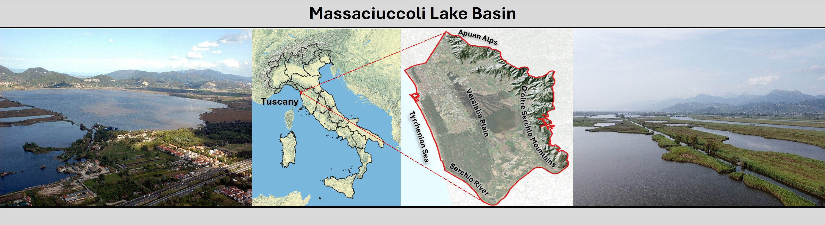
Figure 1: General overview and geographic context of the Massaciuccoli Lake basin wetland, in Tuscany (Italy).



Figure 2: Graphical representation of the developed methodology.

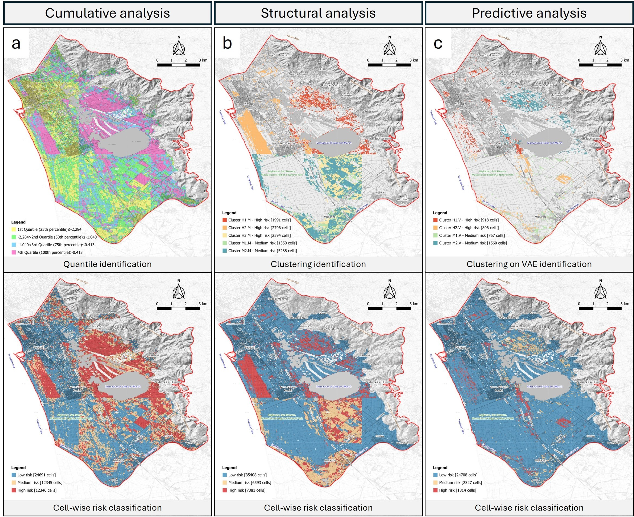
Figure 3: Distribution of the classification results (first row) estimated by the three models included in our methodology (cumulative, structural, and predictive analyses), along with respective cell-wise risk classifications as low/medium/high (second row). The spatial resolution of the cells is approximately 50 m.

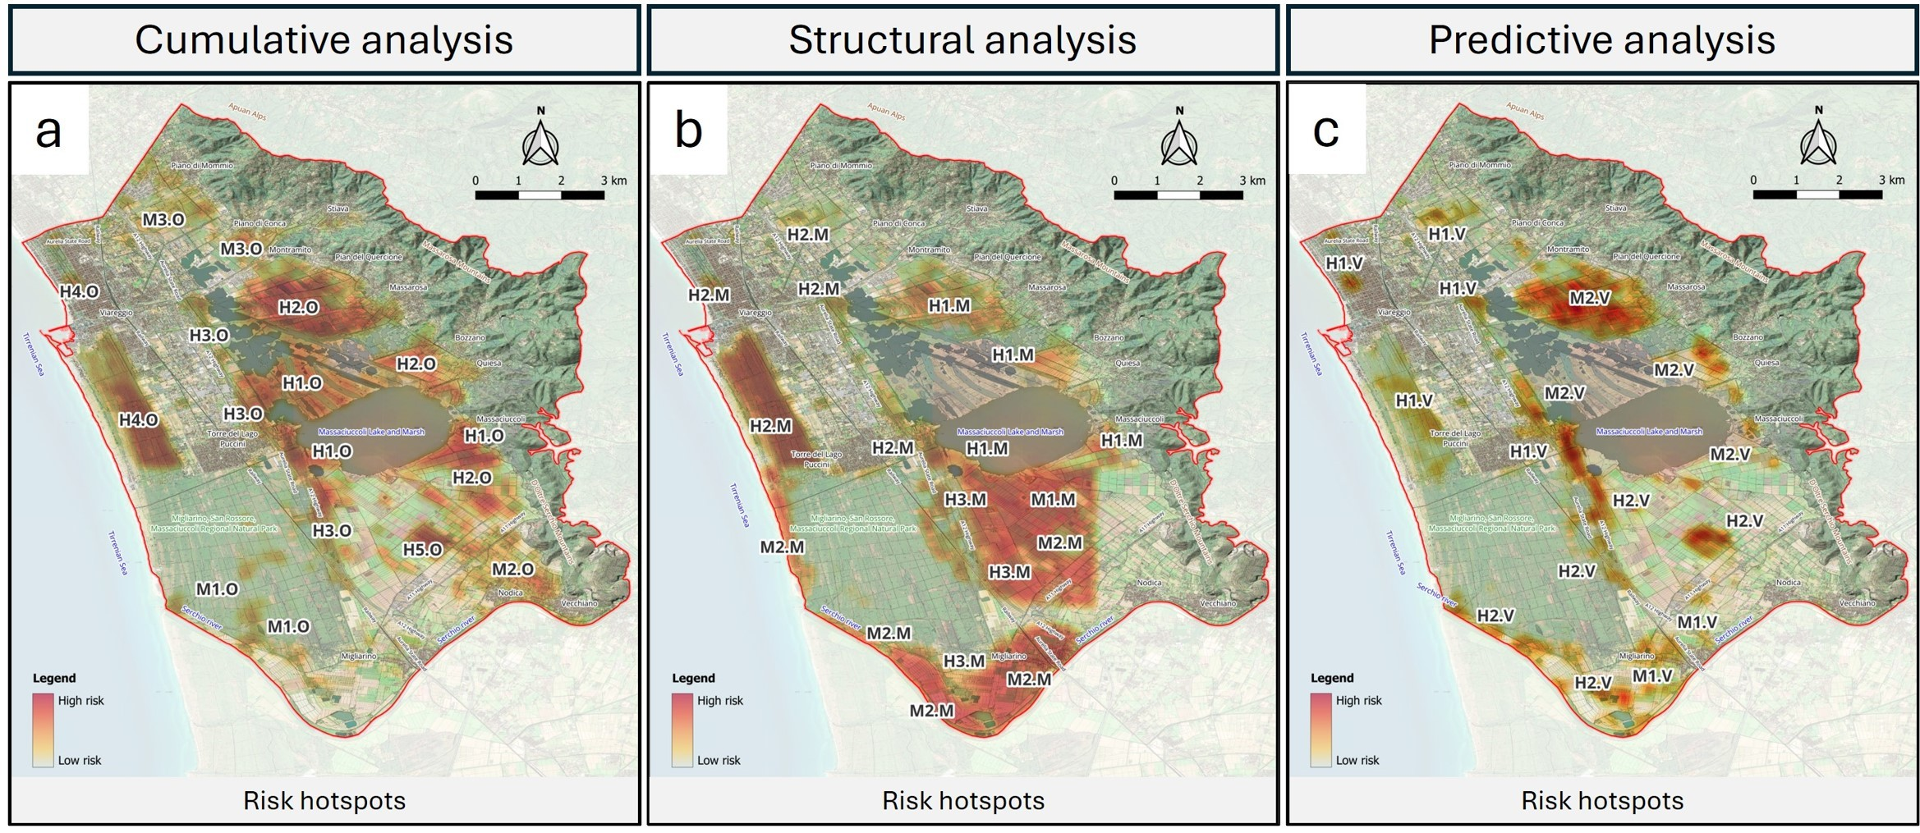
Figure 4: Distribution of the hotspots of ecosystem risk estimated by the three models included in our methodology (cumulative, structural, and predictive analyses). The spatial resolution is approximately 50 m. Labels are intended as references for the characterisations reported in the article. Prefix H indicates hotspots with a prevalence of high-risk cells. Prefix M indicates hotspots with a prevalence of medium-risk cells.

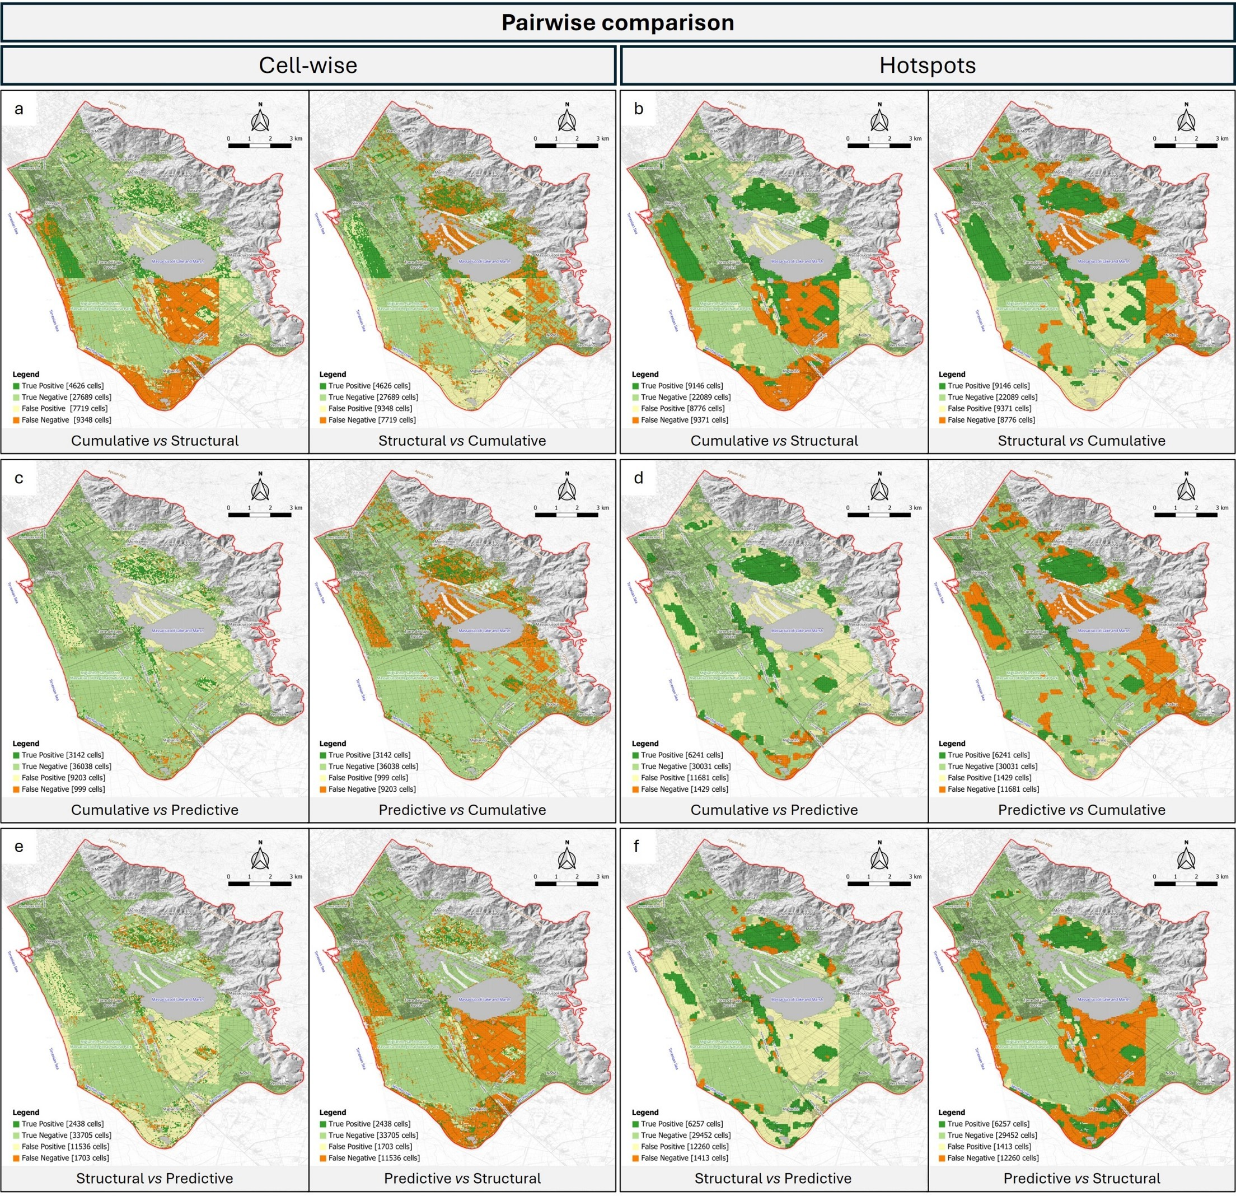
Figure 5: Pairwise differences between the three models included in our methodology (cumulative, structural, and predictive analyses), reported at the levels of the individual cells classified by the models and the hotspot maps. For each map, the first-mentioned model is used as the reference, and the second as the prediction. The spatial resolution of each map is approximately 50 m.

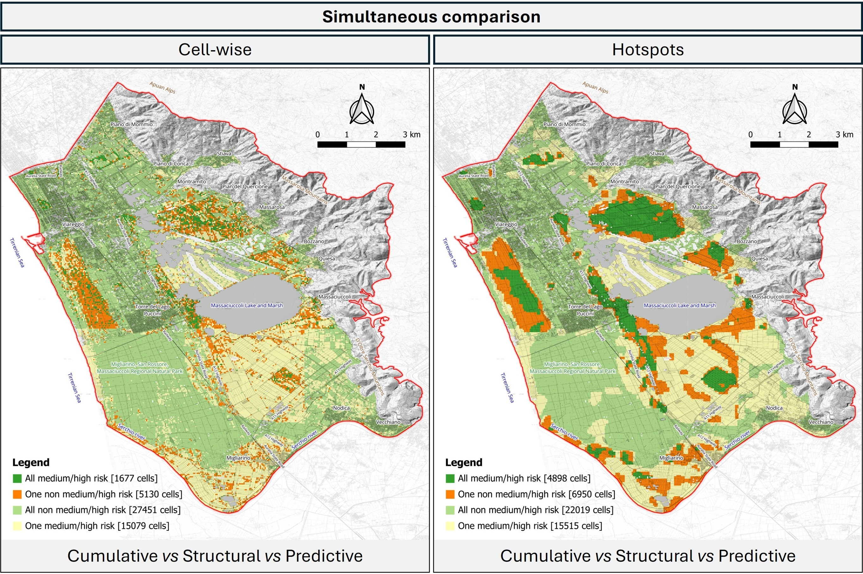

Figure 6: Simultaneous comparison of the three models included in our methodology (cumulative, structural, and predictive analyses), reported at the levels of the individual cells classified by the models and the hotspot maps. Different colours/tones are used to distinguish different agreement conditions among the models. The spatial resolution of the maps is approximately 50 m.

Tables

Table 1: List of the stressor variables used in our methodology. For each variable, the table reports the numeric identifier in the Massaciuccoli Atlas, the stressor name, a general description, the data type (categorial or numeric), our interpretation as a fragile condition or harmful force, whether the variable in the Atlas was used directly or inversely to define the stressor, the unit of measure, and the transformations used for mapping values onto numerical features. All variables represent recent ecosystem conditions (2016–today), derived from single-year datasets, short-term change periods, or aggregated multi-year windows, as described in the Atlas.

Id
(Atlas ref.)
Stressor name
Description
(C)ategorial (F)ragile (I)nverse Unit of Value mapping
(N)umeric condition (D)irect measure
(H)armful Force

3 Land imperviousness density in-
crease
Change in degree of land imperviousness, from
-100% to +100%.
N H D % Non-sealed in both years (stable non-
built up)→100%
Unclassifiable (no satellite image avail-able or clouds or shadows or snow)→NA Outside area→NA
Others→as is

- Tree cover density Level of tree cover density, from 0% to 100%. N F D % As is

- Tree cover density decrease Changes in tree cover density across thematic
classes (unchanged areas with no tree cover / new tree cover / loss of tree cover / unchanged areas with tree cover).

- Grassland cover Classification of grassland cover with two the-matic classes (grassland / non-grassland).
- Grassland cover decrease Changes in grassland vegetation cover across
thematic classes (all non-grassland areas, grassland gain and grassland loss, unchanged grassland in both years and unverified grass-land gain and loss areas).
C H I classes Unchanged areas with no tree cover →0
New tree cover →-1 Loss of tree cover →1
Unchanged areas with tree cover →0 Others→0
C F D classes Grassland→1 0→0
C H I classes Unchanged non-grassland in both
years→0
Grassland gain→-1 Grassland loss→1
Unchanged grassland in both years→0 Unverified grassland gain→-1 Unverified grassland loss→1 Others→0

17 Land use and cover (Natura 2000) hazard area
Land cover and land use in Natura 2000 sites. Only classes with the greatest potential impact on natural ecosystems were selected (i.e., in-dustrial, commercial and military units, min-ing activities, landfills and construction sites, heavily modified watercourses and canals).
C H D classes Industrial→1
Commercial and military units→1 Mineral extraction→1
Dump and construction sites→1
Highly modified water courses and canals→1
Others→0

40 Plant productivity Total productivity as the sum of the daily val-ues of the vegetation phenological index during the growing season. It provides an annual esti-mate of accumulated plant biomass and overall ecosystem productivity.
- Temperature increase Absolute change in air temperature values (ap-
proximately 2 m above the Earth’s surface) rel-ative to the average across 1971–2010.
N F D range As is

N H D °C As is

- Potential evapotranspiration de-crease
Relative change in potential evapotranspira-tion values compared to the average across 1971–2010.
N H I % As is

- Precipitation decrease Relative change in precipitation values per
unit area compared to the average across 1971–2010.
N H I % As is

65 Species richness Biodiversity index based on cumulative species richness, including birds, fish and crustaceans, insects and clams, mammals, reptiles and am-phibians, and other groups.
N F D number of species
As is

147 Land use and cover anthropisation increase
Changes in land use and vegetation cover. Only classes with the greatest potential impact on natural ecosystems were selected (i.e., arti-ficially shaped territories, utilised agricultural areas, Water bodies).
C H D classes Artificially shaped territories→1
Utilised agricultural areas→0.5 Water bodies→-1
Others→0

Table 2: Interpretation and classification of medium and high ecosystem risk by the cumulative analysis. For each area, the table reports a unique identifier, its spatial location, the main fragile conditions present (along with their identifiers in the Massaciuccoli Atlas), and the main harmful forces at work.

Identifier | Localization | Fragile conditions | Harmful forces
High Risk
H1.O | Marshy areas distributed along the perimeter | - High species richness (id 65) | - Moderate reduction in grassland
 | of the lake, with a higher concentration in the  western sector near Torre del Lago Puccini, in |  | cover (id 12)  - High increase in absolute average
 | the north-western sector along the canal net-  work, and in the eastern sector bordering the |  | temperature (id 57)  - High decrease in potential evapotran-
 | town of Massaciuccoli, characterised by hy- |  | spiration (id 58)
 | grophilous vegetation.
H2.O | Agricultural areas immediately adjacent to the | - High presence of grassland cover (id | - High reduction in grassland cover (id
 | lake and marshland, with a higher concentra-  tion in the western sectors near the towns of Pian del Quercione and Massarosa, west of Bozzano and Quiesa, and in the southern sec- | 11)  - High plant growth (id 40)  - High species richness (id 65) | 12)  - High increase in absolute average temperature (id 57)  - High decrease in potential evapotran-
 | tor south of the town of Massaciuccoli. |  | spiration (id 58)
H3.O | Mixed agricultural and wooded areas located between the towns of Viareggio and Torre del Lago Puccini, near the marshland area, ex-tending south-southeast along the A12 motor-way and the Aurelia state road. | - Moderate tree cover density (id 9)  - Moderate presence of grassland cover (id 11)  - High plant growth (id 40)  - High species richness (id 65) | - Moderate reduction in tree cover den-sity (id 10)  - High presence of hazard areas (id 17)  - Moderate increase in absolute aver-age temperature (id 57)  - Moderate decrease in potential evap-
 |  |  | otranspiration (id 58)
H4.O | Agricultural area cultivated with olive groves, | - Moderate tree cover density (id 9) | - High reduction in grassland cover (id
 | located in the south-eastern sector of Massaci-uccoli Lake. | - High presence of grassland cover (id 11)  - Moderate plant growth (id 40)  - Moderate species richness (id 65) | 12)  - High reduction in precipitation (id 59)
H5.O | Wooded area, known as Pineta di Levante, lo-cated between the coast and the urbanised ar-eas of Torre del Lago Puccini and Viareggio. | - High tree cover density (id 9)  - Moderate plant growth (id 40)  - Moderate species richness (id 65) | - Moderate decrease in potential evap-otranspiration (id 58)
Medium Risk
M1.O | Wooded areas within the Migliarino, San Rossore and Massaciuccoli Natural Park, in- | - High tree cover density (id 9)  - Moderate plant growth (id 40) | - High reduction in precipitation (id 59)
 | cluding the area around the mouth of the Ser-
 | chio River.
M2.O | Agricultural areas near and north-east of the | - Moderate species richness (id 65) | - High reduction in precipitation (id
 | towns of Vecchiano and Nodica. |  | 59)
M3.O | Agricultural areas near the urban centres of Piano di Mommio and Piano di Conca | - Moderate tree cover density (id 9)  - Moderate presence of grassland cover (id 11)  - Moderate plant growth (id 40) | - Moderate reduction in grassland cover (id 12)  - High increase in absolute average temperature (id 57)  - High decrease in potential evapotran-
 |  |  | spiration (id 58)

Table 3: Interpretation and classification of medium and high ecosystem risk by the structural analysis. For each area, the table reports a unique identifier, its spatial location, the main fragile conditions present (along with their identifiers in the Massaciuccoli Atlas), and the main harmful forces at work.

Cluster Localization Fragile conditions Harmful forces
High Risk

H1.M Agricultural areas surrounding the lake and marshes, located between neighbouring towns (Montramito, Pian del Quercione, Massarosa, Bozzano, Quiesa and Massaciuccoli). To a lesser degree, it also involves the lacustrine ar-eas, particularly those located to the south-east and south-west of the lake, near Torre del Lago Puccini and Massaciuccoli, characterised by the presence of hygrophilous vegetation.
H2.M Wooded area, known as Pineta di Levante, lo-cated between the coast and the urbanised ar-eas of Torre del Lago Puccini and Viareggio. Smaller wooded areas are located along the highway sections between Torre del Lago Puc-cini and the lake and between Viareggio and the marshland area; within the town of Viareg-gio (Pineta di Ponente); south of the town of Piano di Mommio.
H3.M Agricultural areas located south of the lake, near the town of Migliarino and within the bend of the Serchio River. To a lesser extent, it also includes tree crops distributed along the highway. Cluster complementary to M1.M and M2.M.
- High presence of grassland cover (id 11)
- High plant productivity (id 40)
- High species richness (id 65)

- High tree cover density (id 9)
- High plant growth (id 40)
- High species richness (id 65)

- High plant growth (id 40)
- High species richness (id 65)
- High reduction in grassland cover (id 12)
- High increase in absolute average temperature (id 57)
- High decrease in potential evapotran-spiration (id 58)

- High decrease in potential evapotran-spiration (id 58)

- High reduction in grassland cover (id 12)
- High reduction in precipitation (id 59)

Medium Risk

M1.M Mixed agricultural areas with tree crops lo-cated south of the lake, with a higher con-centration around the town of Migliarino and along the bend of the Serchio River, almost reaching its mouth. Cluster complementary to H3.M and M2.M.
- High presence of grassland cover (id 11)
- High species richness (id 65)
- Moderate reduction in tree cover den-sity (id 10)
- High reduction in precipitation (id 59)

M2.M Agricultural areas located south of the lake, with a higher concentration near the town of Migliarino and along the bend of the Serchio River. It also includes part of the wooded ar-eas near the highway (on the west side) and part of the coastal area (Marina di Vecchi-ano), both of which fall within the Migliarino, San Rossore and Massaciuccoli Natural Park. Cluster complementary to H3.M and M1.M.
- High species richness (id 65) • Moderate reduction in tree cover (id
10)
  - Moderate reduction in grassland cover (id 12)
  - High reduction in precipitation (id 59)

Table 4: Interpretation and classification of medium and high ecosystem risk by the predictive analysis. For each area, the table reports a unique identifier, its spatial location, the main fragile conditions present (along with their identifiers in the Massaciuccoli Atlas), and the main harmful forces at work.

Cluster Localization Fragile conditions Harmful forces
High Risk

H1.V Extensive coverage of the wooded area known as Pineta di Levante, located between the coast and the urbanised areas of Torre del Lago Puccini and Viareggio. Additional mixed forest areas with grass cover are located along sections of the A12 highway between Torre del Lago Puccini and the lake and between Viareg-gio and the marshland area; within the town of Viareggio (Pineta di Ponente); and south of the town of Piano di Mommio.
H2.V Areas covered by trees located: south-east of Torre del Lago along the A12 motorway, the Aurelia state road and the railway; south of the lake (agricultural area planted with olive groves), along the bend of the Serchio river to its mouth.
- High tree cover density (id 9)
- High plant productivity (id 40)
- Consistent species richness (id 65)

- High tree cover density (id 9)
- High plant productivity (id 40)
- High species richness (id 65)
  - Moderate reduction in grassland cover (id 12)
  - High increase in absolute average temperature (id 57)
  - High increase in potential evapotran-spiration (id 58)

  - Moderate reduction in grassland cover (id 12)
  - High reduction in precipitation (id 59)

Medium Risk

M1.V Heterogeneous coverage of agricultural areas located south of the lake. Greater concentra-tion in the vicinity of the town of Migliarino and within the bend of the Serchio River, ex-tending towards the mouth.
M2.V Agricultural areas surrounding the lake and located between neighbouring urban centres (Torre del Lago Puccini, Montramito, Pian del Quercione, Massarosa, Bozzano, Quiesa and Massaciuccoli).
- High presence of grassland cover (id 11)
- High species richness (id 65)

- High presence of grassland cover (id 11)
- Consistent species richness (id 65)
- Moderate reduction in grassland cover (id 12)
- High reduction in precipitation (id 59)

- High increase in absolute average temperature (id 57)
- High decrease in potential evapotran-spiration (id 58)

Table 5: Pairwise comparison metrics for the ecosystem risk assessments produced by the three models compared (cumulative, structural, and predictive analyses). The table reports Accuracy, Precision, Recall, F1 score, and Cohen’s Kappa for cell-wise and heatmap comparisons, with one model serving as the reference and the other as the prediction. Symmetrical values for Accuracy, F1, and Kappa are not reported to avoid information redundancy.
Reference
Reference
Reference
Reference
Reference

 |  | Cell-wise |  |  |  | Hotspots
 |  | Accuracy |  |  |  | Accuracy
 |  | Prediction |  |  |  | Prediction
 | Cumulative | Structural | Predictive |  | Cumulative | Structural | Predictive
Cumulative | — | — | — |  | — | — | —
Structural | 0.65 | — | — |  | 0.63 | — | —
Predictive | 0.79 | 0.73 | — |  | 0.73 | 0.72 | —
 |  | Precision |  |  |  | Precision
 |  | Prediction |  |  |  | Prediction
 | Cumulative | Structural | Predictive |  | Cumulative | Structural | Predictive
Cumulative | — | 0.33 | 0.76 |  | — | 0.51 | 0.81
Structural | 0.37 | — | 0.59 |  | 0.49 | — | 0.82
Predictive | 0.25 | 0.17 | — |  | 0.35 | 0.34 | —
 |  | Recall |  |  |  | Recall
 |  | Prediction |  |  |  | Prediction
 | Cumulative | Structural | Predictive |  | Cumulative | Structural | Predictive
Cumulative | — | 0.37 | 0.25 |  | — | 0.49 | 0.35
Structural | 0.33 | — | 0.17 |  | 0.51 | — | 0.34
Predictive | 0.76 | 0.59 | — |  | 0.81 | 0.82 | —
 |  | F1 score |  |  |  | F1 score
 |  | Prediction |  |  |  | Prediction
 | Cumulative | Structural | Predictive |  | Cumulative | Structural | Predictive
Cumulative | — | — | — |  | — | — | —
Structural | 0.35 | — | — |  | 0.50 | — | —
Predictive | 0.38 | 0.27 | — |  | 0.49 | 0.48 | —
Cohen’s Kappa
Cohen’s Kappa

 |  |  | Prediction |  |  |  | Prediction
 |  | Cumulative | Structural | Predictive |  | Cumulative | Structural | Predictive
Cumulative |  | — | — | — |  | — | — | —
Structural |  | 0.12 | — | — |  | 0.21 | — | —
Predictive |  | 0.29 | 0.16 | — |  | 0.35 | 0.33 | —

Table 6: Quantitative evaluation of the spatial agreement categories from the simultaneous com-parison of the three methods included in our methodology (cumulative, structural, and predictive analyses). The table first summarises the agreement category definitions. Then, for cell-wise and hotspot comparisons separately, it reports the number of cells per category and the relative percent-age. This table is meant to support the interpretation of the colour-coded spatial patterns reported in the related figure.

Agreement category | - Medium/high risk ◦ Non medium/high risk  Cumulative Structural Predictive |  |  |  | Cell-wise  Number of cells | % |  | Hotspots  Number of cells | %
All medium/high risk |  |  |  |  | 1677 | 3.40% |  | 4898 | 9.92%
 | ◦ |  |  |  | 716 |  |  | 1359
One non medium/high risk |  | ◦ |  |  | 1465 | 10.40% |  | 1343 | 14.07%
 |  |  | ◦ |  | 2949 |  |  | 4248
All non medium/high risk | ◦ | ◦ | ◦ |  | 27451 | 55.64% |  | 22019 | 44.59%
 |  | ◦ | ◦ |  | 6254 |  |  | 7433
One medium/high risk | ◦ |  | ◦ |  | 8587 | 30.56% |  | 8012 | 31.42%
 | ◦ | ◦ |  |  | 238 |  |  | 70
 |  | Total |  |  | 49337 | 100.00% |  | 49382 | 100.00%

